

**<<BOOKS SHOPPING ONLINE>>**

**Software Design Specification**

**Group 3**

– Hanoi, July 2023 –

**Record of changes**

| **Date** | **A* M, D** | **In charge** | **Change Description** |
| --- | --- | --- | --- |
| 06/12/2023 | A | create new SDS | add the basic form for project |
| 06/15/2023 | M | add [Code Packages](https://docs.google.com/document/d/1apZfo7-TvS777-WGCfM2OK7HQjI4EUsRSnFeZtsKyng/edit#heading=h.30j0zll) | add code packages, description |
| 06/16/2023 | M | add Database Design | add datatable schema, diagram relationship and table Schema |
| 06/17/2023 | M | add Home Page | modify Class Diagram, Class Specification, Sequence Diagram, Data Queries |
| 06/19/2023 | M | add Products List | modify Class Diagram, Class Specification, Sequence Diagram, Data Queries |
| 06/20/2023 | M | add [Reset Password](https://docs.google.com/document/d/1apZfo7-TvS777-WGCfM2OK7HQjI4EUsRSnFeZtsKyng/edit#heading=) | modify Class Diagram, Class Specification, Sequence Diagram, Data Queries |
| 06/20/2023 | M | add [Change Password](https://docs.google.com/document/d/1apZfo7-TvS777-WGCfM2OK7HQjI4EUsRSnFeZtsKyng/edit#heading=) | modify Class Diagram, Class Specification, Sequence Diagram, Data Queries |
| 06/21/2023 | M | add [Login](https://docs.google.com/document/d/1apZfo7-TvS777-WGCfM2OK7HQjI4EUsRSnFeZtsKyng/edit#heading=) | modify Class Diagram, Class Specification, Sequence Diagram, Data Queries |
| 06/23/2023 | M | add [Register](https://docs.google.com/document/d/1apZfo7-TvS777-WGCfM2OK7HQjI4EUsRSnFeZtsKyng/edit#heading=) | modify Class Diagram, Class Specification, Sequence Diagram, Data Queries |
| 06/23/2023 | M | add [User ProfileProfile](https://docs.google.com/document/d/1apZfo7-TvS777-WGCfM2OK7HQjI4EUsRSnFeZtsKyng/edit#heading=) | modify Class Diagram, Class Specification, Sequence Diagram, Data Queries |
| 06/24/2023 | M | add [PRODUCT DETAIL](https://docs.google.com/document/d/1apZfo7-TvS777-WGCfM2OK7HQjI4EUsRSnFeZtsKyng/edit#heading=) | modify Class Diagram, Class Specification, Sequence Diagram, Data Queries |
| 06/25/2023 | M | add Feedback | modify Class Diagram, Class Specification, Sequence Diagram, Data Queries |
| 06/27/2023 | M | add [Blogs List](https://docs.google.com/document/d/1apZfo7-TvS777-WGCfM2OK7HQjI4EUsRSnFeZtsKyng/edit#heading=) | modify Class Diagram, Class Specification, Sequence Diagram, Data Queries |
| 06/27/2023 | M | add [Produsts List](https://docs.google.com/document/d/1apZfo7-TvS777-WGCfM2OK7HQjI4EUsRSnFeZtsKyng/edit#heading=h.kvl17jm5pfe6) | modify Class Diagram, Class Specification, Sequence Diagram, Data Queries |
| 06/29/2023 | M | add [Sliders List](https://docs.google.com/document/d/1apZfo7-TvS777-WGCfM2OK7HQjI4EUsRSnFeZtsKyng/edit#heading=h.xmd24puqpob) | modify Class Diagram, Class Specification, Sequence Diagram, Data Queries |
| 06/30/2023 | M | add [CartDetail](https://docs.google.com/document/d/1apZfo7-TvS777-WGCfM2OK7HQjI4EUsRSnFeZtsKyng/edit#heading=h.5tge5a1e6frm) | modify Class Diagram, Class Specification, Sequence Diagram, Data Queries |
| 07/01/2023 | M | add [Cart Contact](https://docs.google.com/document/d/1apZfo7-TvS777-WGCfM2OK7HQjI4EUsRSnFeZtsKyng/edit#heading=h.y9dvp8oi2o91) | modify Class Diagram, Class Specification, Sequence Diagram, Data Queries |
| 07/02/2023 | M | add [My orde](https://docs.google.com/document/d/1apZfo7-TvS777-WGCfM2OK7HQjI4EUsRSnFeZtsKyng/edit#heading=h.creltwlv7gkl)r | modify Class Diagram, Class Specification, Sequence Diagram, Data Queries |
| 07/02/2023 | M | add [Order Information](https://docs.google.com/document/d/1apZfo7-TvS777-WGCfM2OK7HQjI4EUsRSnFeZtsKyng/edit#heading=h.oeup4e6rvt7) | modify Class Diagram, Class Specification, Sequence Diagram, Data Queries |
| 07/04/2023 | M | add [BlogDetail](https://docs.google.com/document/d/1apZfo7-TvS777-WGCfM2OK7HQjI4EUsRSnFeZtsKyng/edit#heading=h.cboua77o8dtm) | modify Class Diagram, Class Specification, Sequence Diagram, Data Queries |
| 07/05/2023 | M | add MKT Product Detail | modify Class Diagram, Class Specification, Sequence Diagram, Data Queries |
| 07/07/2023 | M | add [MKT Slider Detail](https://docs.google.com/document/d/1apZfo7-TvS777-WGCfM2OK7HQjI4EUsRSnFeZtsKyng/edit#heading=h.26vtias1z0ll) | modify Class Diagram, Class Specification, Sequence Diagram, Data Queries |
| 07/07/2023 | M | add [Posts List](https://docs.google.com/document/d/1apZfo7-TvS777-WGCfM2OK7HQjI4EUsRSnFeZtsKyng/edit#heading=h.2e2c2xoj0pjc) | modify Class Diagram, Class Specification, Sequence Diagram, Data Queries |
| 07/08/2023 | M | add [Posts Detail](https://docs.google.com/document/d/1apZfo7-TvS777-WGCfM2OK7HQjI4EUsRSnFeZtsKyng/edit#heading=h.26ibmty71jrm) | modify Class Diagram, Class Specification, Sequence Diagram, Data Queries |
| 07/09/2023 | M | add [Sale Dashboard](https://docs.google.com/document/d/1apZfo7-TvS777-WGCfM2OK7HQjI4EUsRSnFeZtsKyng/edit#heading=h.9g24akjt8kph) | modify Class Diagram, Class Specification, Sequence Diagram, Data Queries |
| 07/09/2023 | M | add [Orders Details](https://docs.google.com/document/d/1apZfo7-TvS777-WGCfM2OK7HQjI4EUsRSnFeZtsKyng/edit#heading=h.ijwbwr39reyu) | modify Class Diagram, Class Specification, Sequence Diagram, Data Queries |
| 07/09/2023 | M | add Order List | modify Class Diagram, Class Specification, Sequence Diagram, Data Queries |
| 07/10/2023 | M | add [User List](https://docs.google.com/document/d/1apZfo7-TvS777-WGCfM2OK7HQjI4EUsRSnFeZtsKyng/edit#heading=h.jgsr0b3x9u61) | modify Class Diagram, Class Specification, Sequence Diagram, Data Queries |
| 07/11/2023 | M | add [User Details](https://docs.google.com/document/d/1apZfo7-TvS777-WGCfM2OK7HQjI4EUsRSnFeZtsKyng/edit#heading=h.92ingsz1do2i) | modify Class Diagram, Class Specification, Sequence Diagram, Data Queries |
| 07/11/2023 | M | add [Setting List](https://docs.google.com/document/d/1apZfo7-TvS777-WGCfM2OK7HQjI4EUsRSnFeZtsKyng/edit#heading=h.2kwn2340zws1) | modify Class Diagram, Class Specification, Sequence Diagram, Data Queries |
| 07/11/2023 | M | add [Setting Details](https://docs.google.com/document/d/1apZfo7-TvS777-WGCfM2OK7HQjI4EUsRSnFeZtsKyng/edit#heading=h.4u2doxak5ao4) | modify Class Diagram, Class Specification, Sequence Diagram, Data Queries |
| 07/12/2023 | M | add [Admin DashBoard](https://docs.google.com/document/d/1apZfo7-TvS777-WGCfM2OK7HQjI4EUsRSnFeZtsKyng/edit#heading=h.7neoyat5i0e2) | modify Class Diagram, Class Specification, Sequence Diagram, Data Queries |
| 07/12/2023 | M | add [Feedback List](https://docs.google.com/document/d/1apZfo7-TvS777-WGCfM2OK7HQjI4EUsRSnFeZtsKyng/edit#heading=h.ezi8ekf59371) | modify Class Diagram, Class Specification, Sequence Diagram, Data Queries |
| 07/13/2023 | M | add [Feedback Detail](https://docs.google.com/document/d/1apZfo7-TvS777-WGCfM2OK7HQjI4EUsRSnFeZtsKyng/edit#heading=h.52q9elpdgk5a) | modify Class Diagram, Class Specification, Sequence Diagram, Data Queries |
| 07/13/2023 | M | add [Customer List](https://docs.google.com/document/d/1apZfo7-TvS777-WGCfM2OK7HQjI4EUsRSnFeZtsKyng/edit#heading=h.recmyfn1dbkm) | modify Class Diagram, Class Specification, Sequence Diagram, Data Queries |
| 07/13/2023 | M | add [Customer Detail](https://docs.google.com/document/d/1apZfo7-TvS777-WGCfM2OK7HQjI4EUsRSnFeZtsKyng/edit#heading=h.2ntoxwlhjgsl) | modify Class Diagram, Class Specification, Sequence Diagram, Data Queries |
| 07/14/2023 | M | add [Authorization](https://docs.google.com/document/d/1apZfo7-TvS777-WGCfM2OK7HQjI4EUsRSnFeZtsKyng/edit#heading=h.6daj4has1m2h) | modify Class Diagram, Class Specification, Sequence Diagram, Data Queries |
| 07/14/2023 | M | add CartCompletion | modify Class Diagram, Class Specification, Sequence Diagram, Data Queries |

*A - Added M - Modified D - Deleted

**Table of Contents**

**I. Overview 9**

1. Code Packages 9

2. Database Design 10

a. Database Schema 10

b. Table Description 11

**II. Code Designs 15**

1. Public/Home Page 15

a. Class Diagram 15

b. Class Specifications 16

c. Sequence Diagram(s) 17

d. Database Queries 17

2. Public/Products List 18

a. Class Diagram 18

b. Class Specifications 18

c. Sequence Diagram(s) 19

d. Database queries 19

3. <Common/Reset Password> 20

a. Class Diagram 20

b. Class Specifications 20

c. Sequence Diagram(s) 21

d. Database queries 21

4. <Common/Change Password> 22

a. Class Diagram 22

b. Class Specifications 22

c. Sequence Diagram(s) 23

d. Database queries 23

5. <Common/Login> 24

a. Class Diagram 24

b. Class Specifications 24

c. Sequence Diagram(s) 25

d. Database queries 25

6. <Common/Register> 26

a. Class Diagram 26

b. Class Specifications 26

c. Sequence Diagram(s) 27

d. Database queries 27

7. <Common/User ProfileProfile> 28

a. Class Diagram 28

b. Class Specifications 28

c. Sequence Diagram(s) 29

d. Database queries 29

8. <Public/PRODUCT DETAIL> 30

a. Class Diagram 30

b. Class Specifications 30

c. Sequence Diagram(s) 31

d. Database queries 31

9. <Common/Feedback > 32

a. Class Diagram 32

b. Class Specifications 32

c. Sequence Diagram(s) 33

d. Database queries 33

10. Public/Blogs List 34

a. Class Diagram 34

b. Class Specifications 34

c. Sequence Diagram(s) 35

d. Database queries 35

11.Marketing/Produsts List 36

a. Class Diagram 36

b. Class Specifications 36

c. Sequence Diagram(s) 37

d. Database queries 37

12.Marketing/Sliders List 38

a. Class Diagram 38

b. Class Specifications 38

c. Sequence Diagram(s) 38

d. Database queries 38

13.Public/CartDetail 39

a. Class Diagram 39

b. Class Specifications 39

c. Sequence Diagram(s) 40

d. Database queries 40

14.Public/Cart Contact 41

a. Class Diagram 41

b. Class Specifications 41

c. Sequence Diagram(s) 42

d. Database queries 42

15.My order 42

a. Class Diagram 42

b. Class Specifications 42

c. Sequence Diagram(s) 43

d. Database queries 43

16.Order Information 44

a. Class Diagram 44

b. Class Specifications 44

c. Sequence Diagram(s) 45

d. Database queries 45

17.Public/BlogDetail 47

a. Class Diagram 47

b. Class Specifications 47

c. Sequence Diagram(s) 48

d. Database queries 48

18.Marketing/MKT Dashboard 48

a. Class Diagram 48

b. Class Specifications 49

c. Sequence Diagram(s) 49

d. Database queries 49

19.Marketing/MKT Product Detail 50

a. Class Diagram 50

b. Class Specifications 50

c. Sequence Diagram(s) 51

d. Database queries 51

20.Marketing/MKT Slider Detail 52

a. Class Diagram 52

b. Class Specifications 52

c. Sequence Diagram(s) 53

d. Database queries 53

21.Marketing/Posts List 54

a. Class Diagram 54

b. Class Specifications 54

c. Sequence Diagram(s) 55

d. Database queries 55

22.Marketing/Posts Detail 56

a. Class Diagram 56

b. Class Specifications 57

c. Sequence Diagram(s) 58

d. Database queries 58

23.Sale/Sale Dashboard 59

a. Class Diagram 59

b. Class Specifications 59

c. Sequence Diagram(s) 60

d. Database queries 60

24.Sale/Orders Details 61

a. Class Diagram 61

b. Class Specifications 62

c. Sequence Diagram(s) 63

d. Database queries 63

25.Sale/Order List 64

a. Class Diagram 64

b. Class Specifications 64

c. Sequence Diagram(s) 65

d. Database queries 65

26.Admin/User List 66

a. Class Diagram 66

b. Class Specifications 66

c. Sequence Diagram(s) 67

d. Database queries 67

27.Admin/User Details 68

a. Class Diagram 68

b. Class Specifications 68

c. Sequence Diagram(s) 69

d. Database queries 69

28.Admin/Setting List 70

a. Class Diagram 70

b. Class Specifications 70

c. Sequence Diagram(s) 70

d. Database queries 71

29.Admin/Setting Details 72

a. Class Diagram 72

b. Class Specifications 72

c. Sequence Diagram(s) 72

d. Database queries 72

30.Admin/Admin DashBoard 73

a. Class Diagram 73

b. Class Specifications 73

c. Sequence Diagram(s) 74

d. Database queries 74

31.Marketing/Feedback List 75

a. Class Diagram 75

b. Class Specifications 75

c. Sequence Diagram(s) 76

d. Database queries 76

32.Marketing/Feedback Detail 77

a. Class Diagram 77

b. Class Specifications 77

c. Sequence Diagram(s) 77

d. Database queries 77

33.Marketing/Customer List 78

a. Class Diagram 78

b. Class Specifications 79

c. Sequence Diagram(s) 79

d. Database queries 79

34.Marketing/Customer Detail 81

a. Class Diagram 81

b. Class Specifications 81

c. Sequence Diagram(s) 82

d. Database queries 82

35. <Common/Authorization > 83

a. Class Diagram 84

b. Class Specifications 84

c. Sequence Diagram(s) 85

d. Database queries 86

36.Public/CartCompletion 86

a. Class Diagram 86

b. Class Specifications 88

c. Sequence Diagram(s) 89

d. Database queries 90

# I. Overview

## 1. Code Packages

*[Provide the package diagram for each sub-system. The content of this section including the overall package diagram, the explanation, package and class naming conventions in each package. Please see the sample & description table format below (****please note: package names don’t follow Java package naming convention yet****)]*

***Package descriptions & package class naming conventions***

| **No** | **Package** | **Description** |
| --- | --- | --- |
| *01* | *controller* | *Acts as a go-between for the service layer and the Front-end, passing on different input requests.* |
| *02* | *dal* | *This component is used to get data directly FROM the database.* |
| *03* | *configs* | *This component helps define configuration.* |
| *04* | *context* | *This component helps connect databases.* |
| *05* | *model* | *This component includes interfaces used to receive data retrieved FROM the database and classes used to receive data.* |
| *05* | *view* | *This component displays front-end.* |

## 2. Database Design

### a. Database Schema

*[Provide the tables relationship like example below – following MySQL database naming convention]*

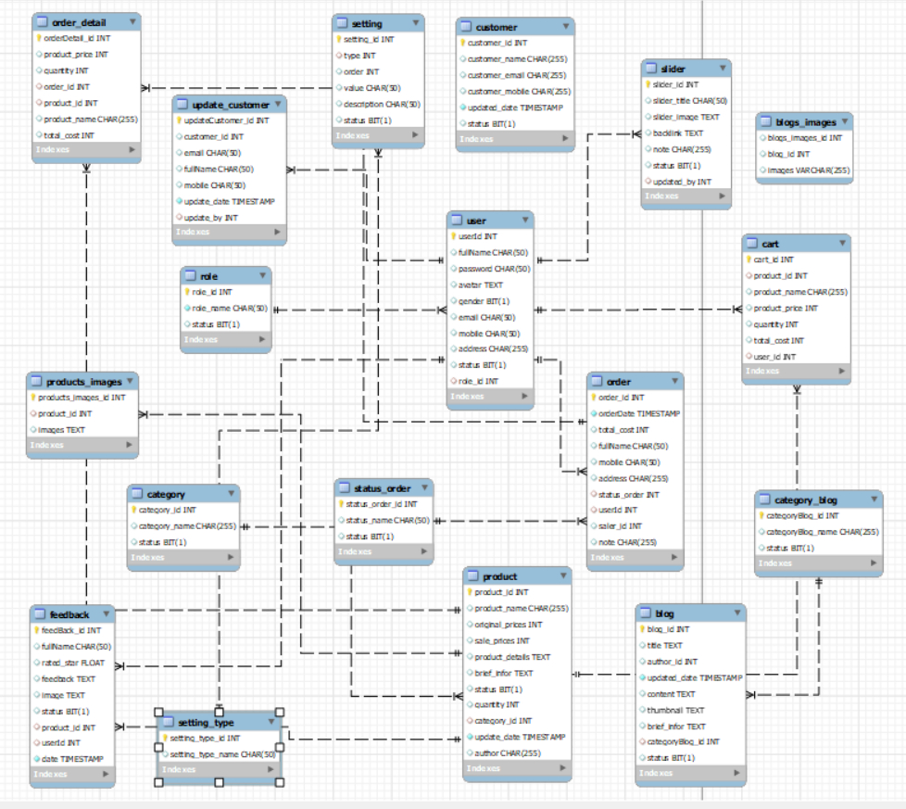

### b. Table Description

| **#** | **Table** | **Description** |
| --- | --- | --- |
| 1 | User | userId int ,  fullName nvarchar(50),  password varchar(50),  avatar varbinary(max),  gender bit,  email varchar(50),  mobile varchar(50),  role_id int,  [address] nvarchar(255),  [status] nvarchar(50)  **Primary key: userId**  **Foreign key: role_id** |
| 2 | Role | role_id int,  role_name varchar(50)  **Primary key: role_id** |
| 3 | Category | category_id int,  category_name nvarchar(50)  **Primary key: category_id** |
| 4 | Product | product_id,  product_name nvarchar(255),  category_id int,  brief_infor  original_prices float,  sale_prices float,  product_details nvarchar(max),  quantity int,  Status nvarchar(50)  Author nvarchar(50)  **Primary key: product_id**  **Foreign key: category_id** |
| 5 | Product_Images | Product_Images_id int,  Product_id int,  images varchar(max)  **Primary key: statusOrder_id**  **Foreign key: Product_id** |
| 6 | Order | order_id int,  fullName nvarchar(50),  email varchar(50),  mobile varchar(50),  Address nvarchar(255),  orderDate date,  total_cost float,  statusOrder_id int,  user_id int  **Primary key: order_id**  **Foreign key: user_id** |
| 7 | orderDetail | orderDetail_id int,  product_id int,  prices float,  quantity int,  order_id int  **Primary key: orderDetail_id**  **Foreign key:product_id int_id** |
| 8 | Feedback | feedBack_id int,  fullName nvarchar(50),  rated_star float,  feedback nvarchar(max),  image_status varbinary(max),  Status bit,  product_id int,  userId int,  **Primary key: feedBack_id**  **Foreign key: product_id, userId** |
| 9 | categoryBlog | categoryBlog_id int,  categoryBlog_name nvarchar(50)  **Primary key: categoryBlog_id** |
| 10 | Blog | blog_id int,  title nvarchar(50),  author_id int,  updated_date date,  content text,  Thumbnail text,  Brief_infor nvarchar(255)  categoryBlog_id int,  **Primary key: blog_id**  **Foreign key: author_id, categoryBlog_id** |
| 11 | UpdateCustomer | udateCustomer_id int,  email varchar(50),  fullName nvarchar(50),  Gender bit,  mobile varchar(50),  Address nvarchar(255)  updated_date date,  updated_by int,  **Primary key: udateCustomer_id**  **Foreign key: updated_by** |
| 12 | Slider | slider_id int,  slider_title nvarchar(50),  Slider_images text,  Backlink varchar(max),  Note nvarchar(50),  Status int,  update_by int,  **Primary key: slider_id**  **Foreign key: update_by** |

# II. Code Designs

## 1. Public/Home Page

### a. Class Diagram

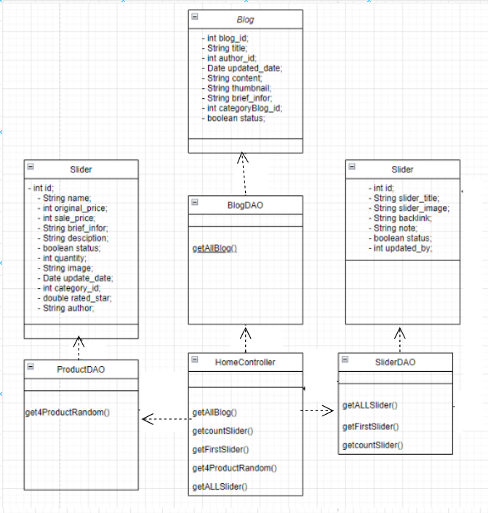

### b. Class Specifications

*Provide the description for each class and the methods in each class, following the table format as below]*

*[Provide the detailed description for the class methods]*

| **No** | **Method** | **Description** |
| --- | --- | --- |
| *01* | *getAllIBlog()* | *get 2 Blog random from Blog* |
| *02* | *getFirstSlider()* | *get all property in slider first* |
| *03* | *getALLSlider()* | *get all property in slider* |
| *04* | *get4ProductRandom ()* | *get 4 product random from products* |
| *05* | *getcountSlider()* | *count All Slide* |

### c. Sequence Diagram(s)

*[Provide the sequence diagram(s) for the feature, see the sample below]*

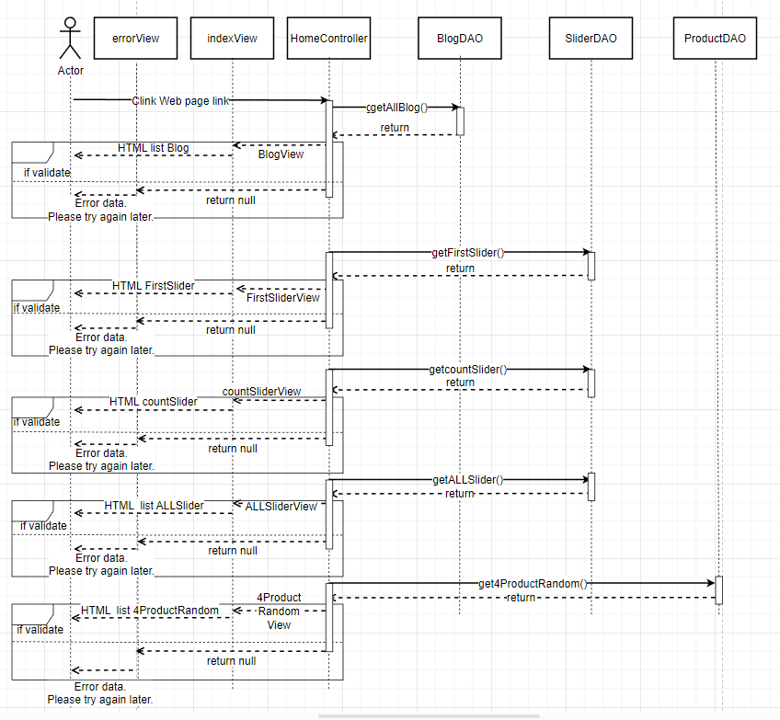

### d. Database Queries

*[Provide the detailed SQL (select, insert, update...) which are used in implementing the function/screen]*

SELECT count (*) FROM books_shop_online.slider where status = 1

SELECT * FROM books_shop_online.slider WHERE status = 1 LIMIT 1;

SELECT * FROM Slider where status = 1

SELECT * FROM Product ORDER BY RAND () LIMIT 4;

SELECT * FROM books_shop_online.blog ORDER BY RAND() LIMIT 2

## 2. Public/Products List

### a. Class Diagram

# 

### b. Class Specifications

| **No** | **Method** | **Description** |
| --- | --- | --- |
| *01* | *getTotalProduct()* | *Get the amount of all products* |
| *02* | *getProductWithPaging()* | *Get all product pagination in database* |
| *03* | *getAllCategory()* | *Get all category in database* |
| *04* | *getProductNew()* | *Get a product latest post* |
| *05* | *getFirst()* | *Get first slider in database* |
| *06* | *getAll()* | *Get all slider in database* |

### c. Sequence Diagram(s)

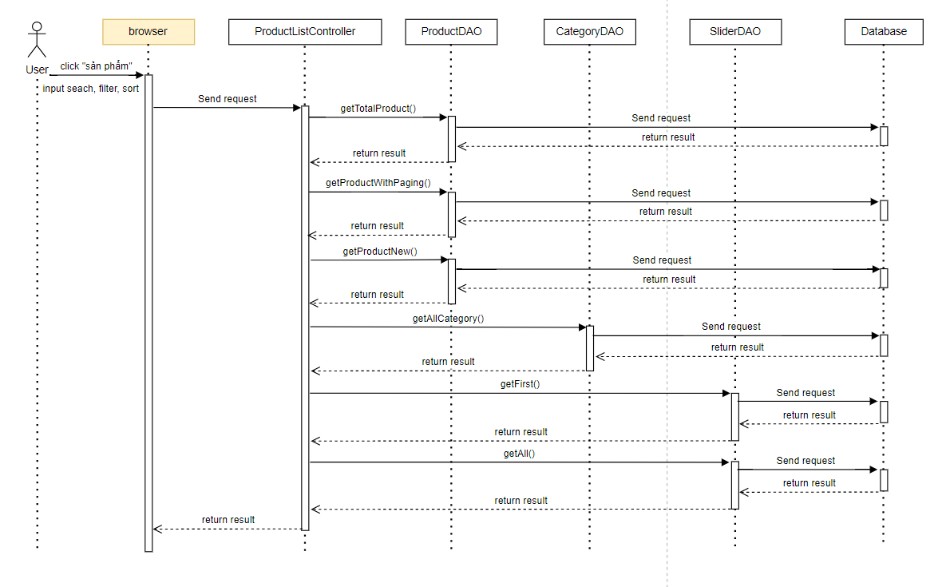

### d. Database queries

* SELECT COUNT(product_id) FROM Product\n"

+ "WHERE category_id " + categoryId + " AND status " + status + " AND product_name LIKE '%" + searchKey + "%';

* select * from product\n"

+ "where category_id " + categoryId + " and status " + status + " and product_name like N'%" + searchKey + "%'\n"

+ " order by " + value + " " + type + " LIMIT ?, ?;

* Select * from Category where status = 1
* SELECT * FROM Product ORDER BY update_date DESC LIMIT 1;
* SELECT * FROM Slider

## 3. <Common/Reset Password>

### a. Class Diagram

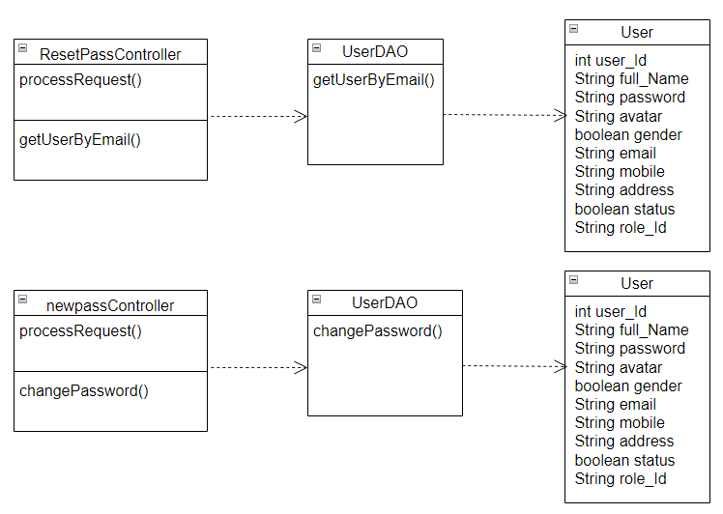

### b. Class Specifications

| **No** | **Method** | **Description** |
| --- | --- | --- |
| *01* | *getUserByEmail()* | *get User By Email* |
| *02* | *changePassword()* | *change Password* |

### c. Sequence Diagram(s)

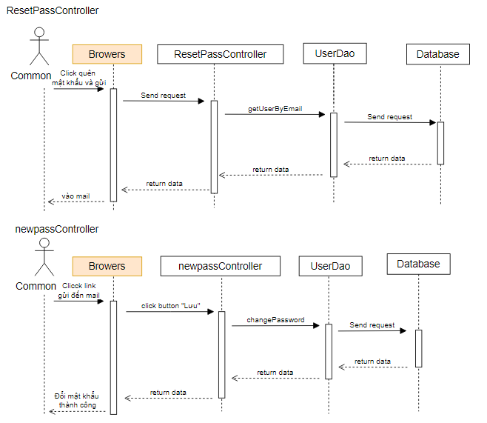

### d. Database queries

* "select * from user where email = ?"
* "UPDATE `User` SET `password` = ? WHERE `userId` = ?"

## 4. <Common/Change Password>

### a. Class Diagram

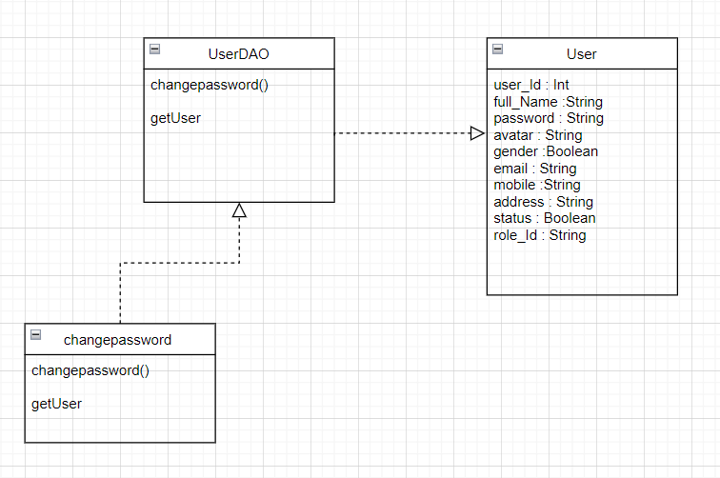

### b. Class Specifications

| **No** | **Method** | **Description** |
| --- | --- | --- |
| *01* | *getUser()* | *Get the user's old password* |
| *02* | *changePassword()* | *Change the new password to the database* |

### c. Sequence Diagram(s)

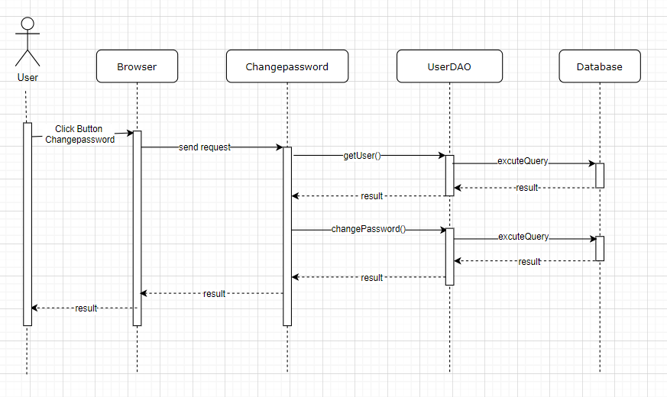

### d. Database queries

* SELECT * FROM `User` WHERE userId = ?
* UPDATE `User`\n"

+ " SET \n"

+ " `password` = ?\n"

+ " WHERE `userId` = ?

## 5. <Common/Login>

### a. Class Diagram

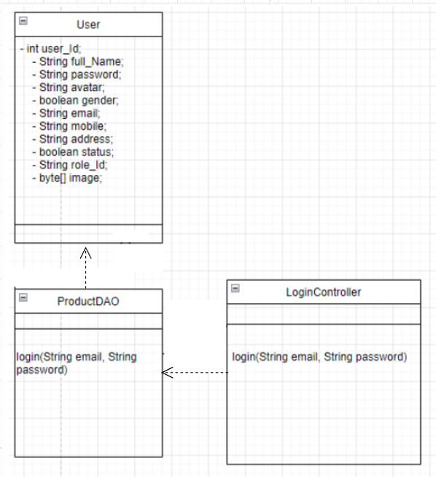

### b. Class Specifications

#### 

| **No** | **Method** | **Description** |
| --- | --- | --- |
| *01* | *Login(String email, String password)***l** | *Using to login into the system* |

### c. Sequence Diagram(s)

### 

### d. Database queries

select * from user\n"

+ "where email = ? and password = ?

## 6. <Common/Register>

### a. Class Diagram

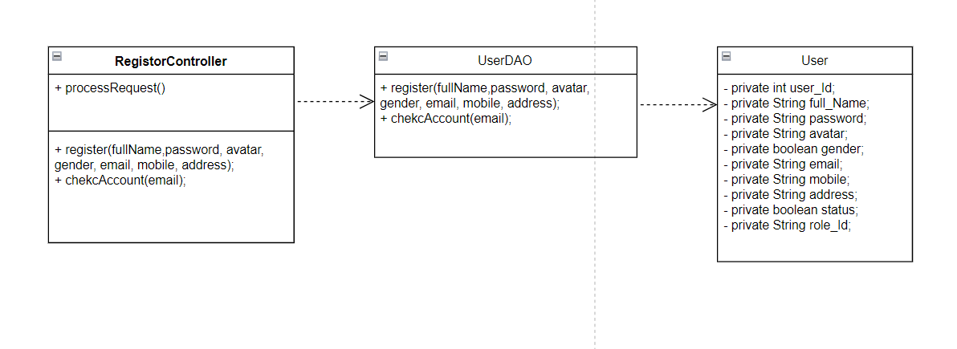

### b. Class Specifications

| **No** | **Method** | **Description** |
| --- | --- | --- |
| *01* | *Register()* | *use to create new user* |
| *02* | *chekcAccount()* | *use to check email exist* |

### c. Sequence Diagram(s)

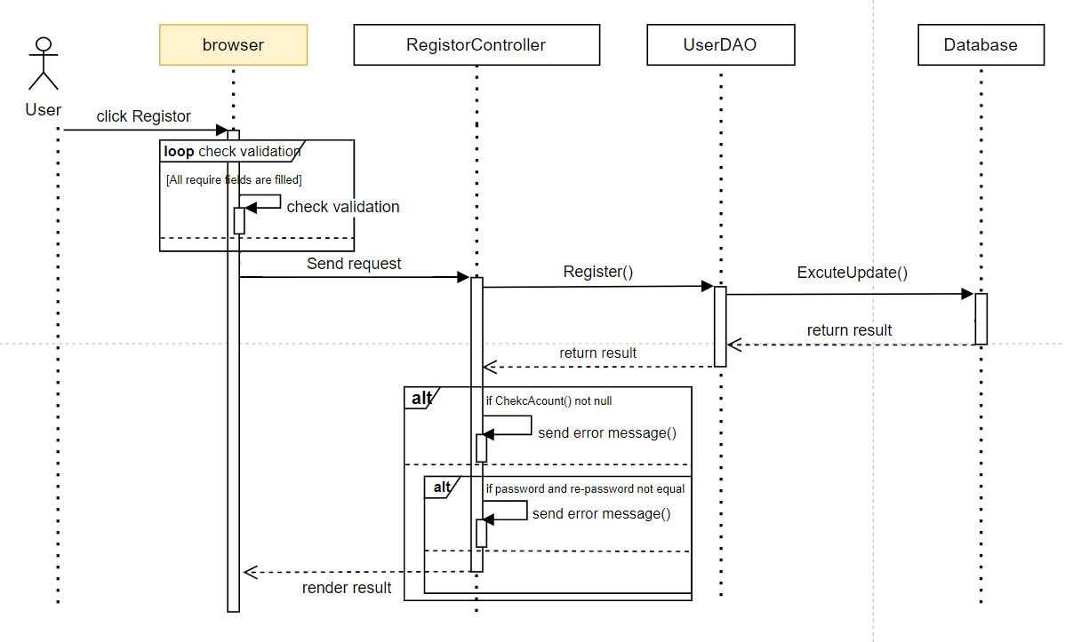

### d. Database queries

* select * from user where email = ?
* "INSERT INTO user (`fullName`, `password`,`gender`, `email`, `mobile`, `address`, `status`, `role_id`) VALUES \n"

+ "(?,?,b?,?,?,?,0,1)"

## 7. <Common/User ProfileProfile>

### a. Class Diagram

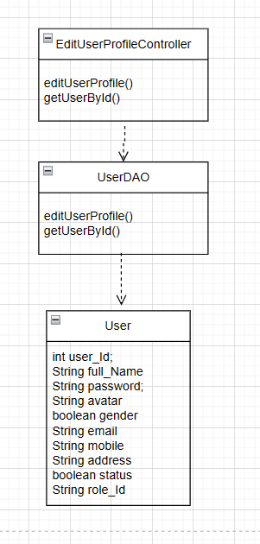

### b. Class Specifications

| **No** | **Method** | **Description** |
| --- | --- | --- |
| *01* | *getUserById()* | *get User By Id* |
| *02* | *editUserProfile()* | *use to update user’s profile* |

### c. Sequence Diagram(s)

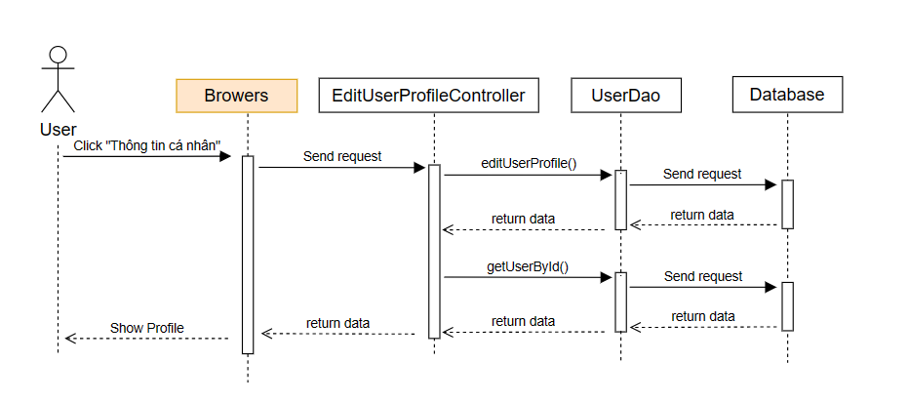

### d. Database queries

update books_shop_online.User\n"

+ "set fullName = ?,\n"

+ "avatar = ?,\n"

+ "gender = ?,\n"

+ "mobile = ?,\n"

+ "address = ?\n"

+ "where userId = ?

select * from books_shop_online.user where userId = ?

## 8. <Public/PRODUCT DETAIL>

### a. Class Diagram

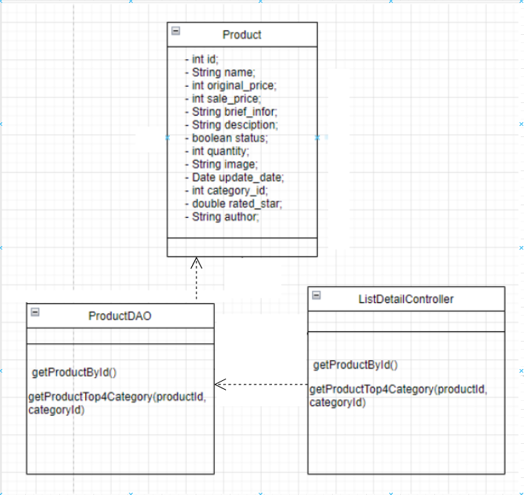

### b. Class Specifications

| **No** | **Method** | **Description** |
| --- | --- | --- |
| *01* | *getProductById()* | *Use to retrieve products by ID* |
| *02* | *getProductTop4Category(productId, categoryId)* | *get top 4 product have Category relate to* |

### c. Sequence Diagram(s)

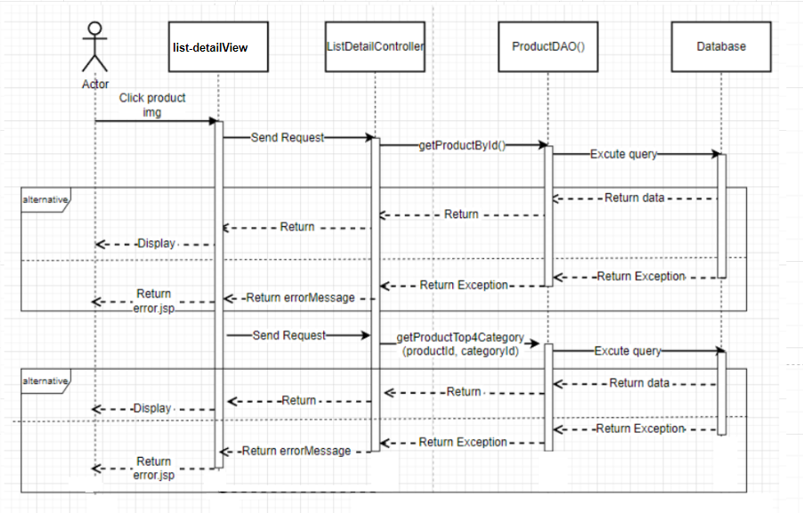

### d. Database queries

* select * from Product where product_id = ?;
* SELECT * FROM Product WHERE category_id = ? AND product_id != ? ORDER BY RAND() LIMIT 4

## 

## 

## 

## 9. <Common/Feedback >

### a. Class Diagram

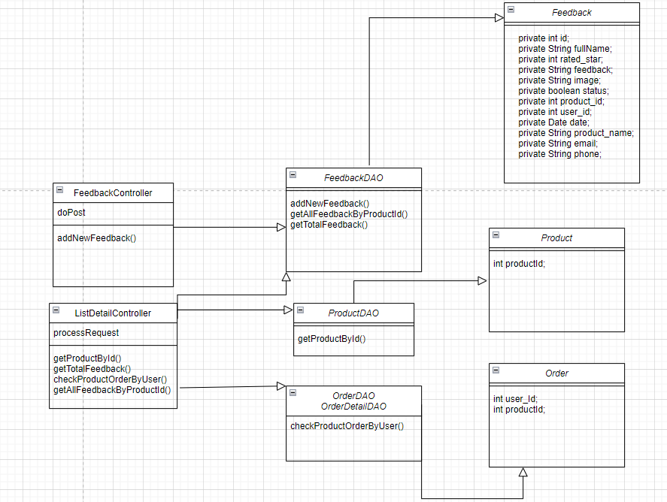

### b. Class Specifications

| **No** | **Method** | **Description** |
| --- | --- | --- |
| *01* | *addNewFeedback()* | *add new user feedback* |
| *02* | *getProductById()* | *get product id* |
| *03* | *getTotalFeedback()* | *get total user feedback* |
| *04* | *checkProductOrderByUser()* | *Check if the user has ordered the product or not* |
| *05* | *getAllFeedbackByProductId()* | *print all product responses to the screen* |

### c. Sequence Diagram(s)

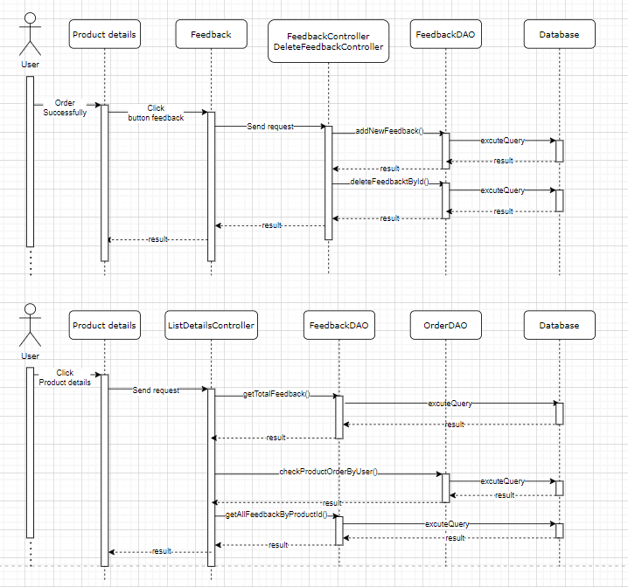

### d. Database queries

- INSERT INTO `books_shop_online`.`feedback` ( `fullName`, `rated_star`, `feedback`, `image`, `status`, `product_id`, `userId`) VALUES (?, ?, ?, ?, ?, ?, ?)"

## 10. Public/Blogs List

### a. Class Diagram

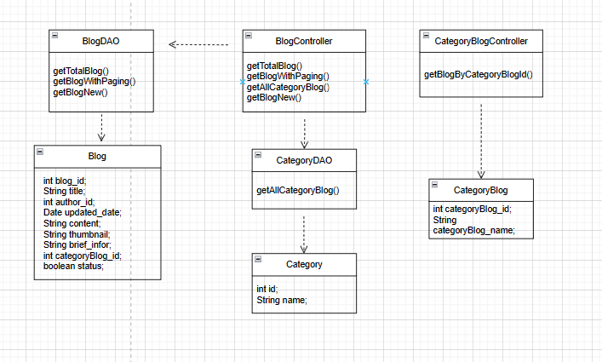

### b. Class Specifications

| **No** | **Method** | **Description** |
| --- | --- | --- |
| *01* | *getTotalBlog()* | *Get the amount of all Blogs* |
| *02* | *getBlogWithPaging()* | *Get all Blog pagination in database* |
| *03* | *getAllCategoryBlog()* | *Get all category in database* |
| *04* | *getBlogNew()* | *Get a blog latest post* |

### c. Sequence Diagram(s)

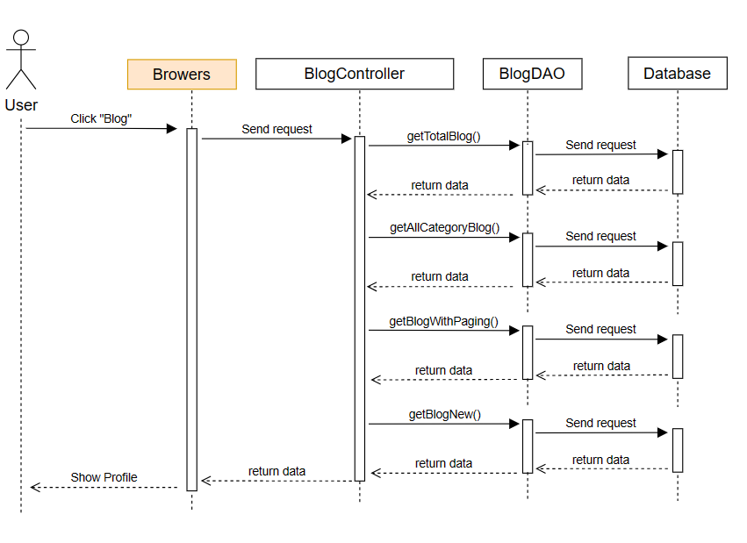

### d. Database queries

-SELECT COUNT(*)\n"

+ "FROM books_shop_online.blog\n"

+ "WHERE categoryBlog_id = "+ categoryId+"\n"

+ " AND status = 1\n"

+ " AND title LIKE CONCAT('%', '"+searchKey+"', '%');

* select * from books_shop_online.blog \n"

+ "where categoryBlog_id " + categoryId + " and status = 1 and title like N'%" + searchKey + "%'\n"

+ " order by " + value + " " + type + " LIMIT ?, ?;

* Select * from books_shop_online.category_blog where status = 1
* SELECT *\n"
* + "FROM books_shop_online.blog\n"
* + "WHERE status = 1\n"
* + "ORDER BY updated_date DESC\n"
* + "LIMIT 1;

## 11.Marketing/Produsts List

### a. Class Diagram

## 

## 

### b. Class Specifications

| **No** | **Method** | **Description** |
| --- | --- | --- |
| *01* | *getTotalPublishedProduct()* | *Get total of all pushlish Product* |
| *02* | *getTotalProduct()* | *Get total of all Product* |
| *03* | *getTotalProduct(searchKey, categoryId, status)* | *Get all product by searching, filter* |
| *04* | *getProductWithPaging()* | *Get Product with page* |
| *05* | *getAllCategory()* | *Get All category for filter product* |

### c. Sequence Diagram(s)

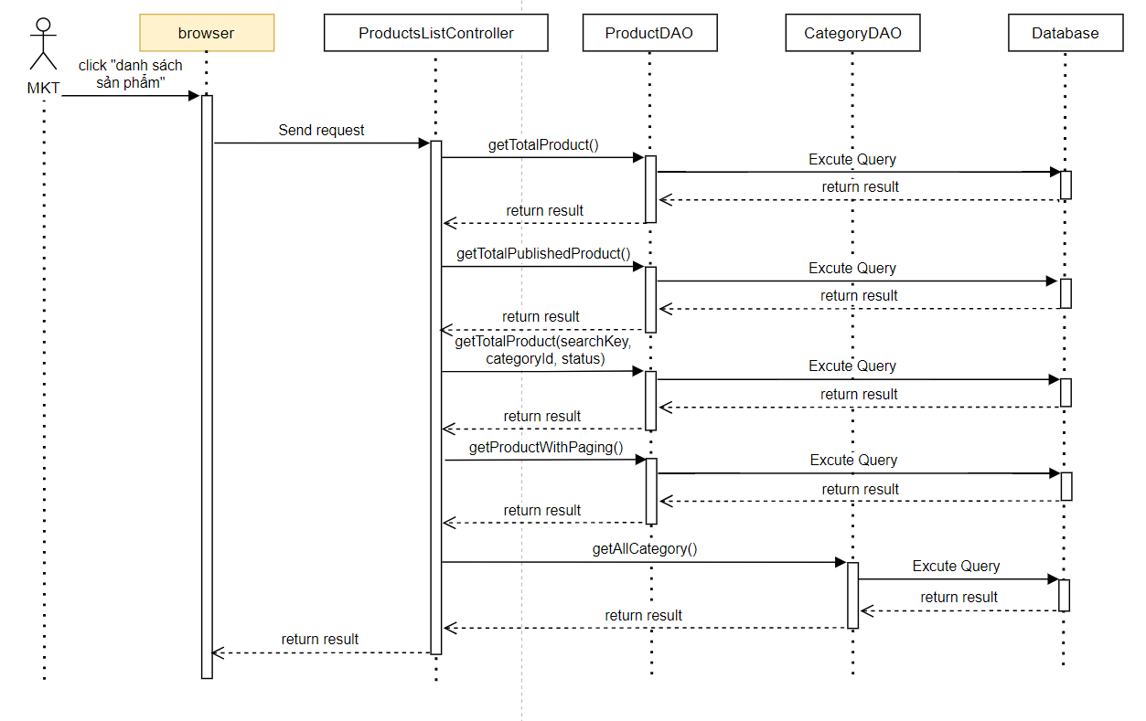

### d. Database queries

* select COUNT(product_id) from Product;
* select COUNT(product_id) from Product where status = 1;
* SELECT COUNT(product_id) FROM Product\n"

+ "WHERE category_id " + categoryId + " AND status " + status + " AND product_name LIKE '%" + searchKey + "%';

* select * from product\n"

+ "JOIN products_images ON product.`product_id` = products_images.`product_id`"

+ "where category_id " + categoryId + " and status " + status + " and product_name like N'%" + searchKey + "%'\n"

+ " order by " + value + " " + type + " LIMIT ?, ?;

* Select * from books_shop_online.category where status = 1

## 12.Marketing/Sliders List

### a. Class Diagram

### 

### b. Class Specifications

| **No** | **Method** | **Description** |
| --- | --- | --- |
| *01* | *getALLSlider_True_False(status)* | *Get all Slider by status (default null) in database* |

### c. Sequence Diagram(s)

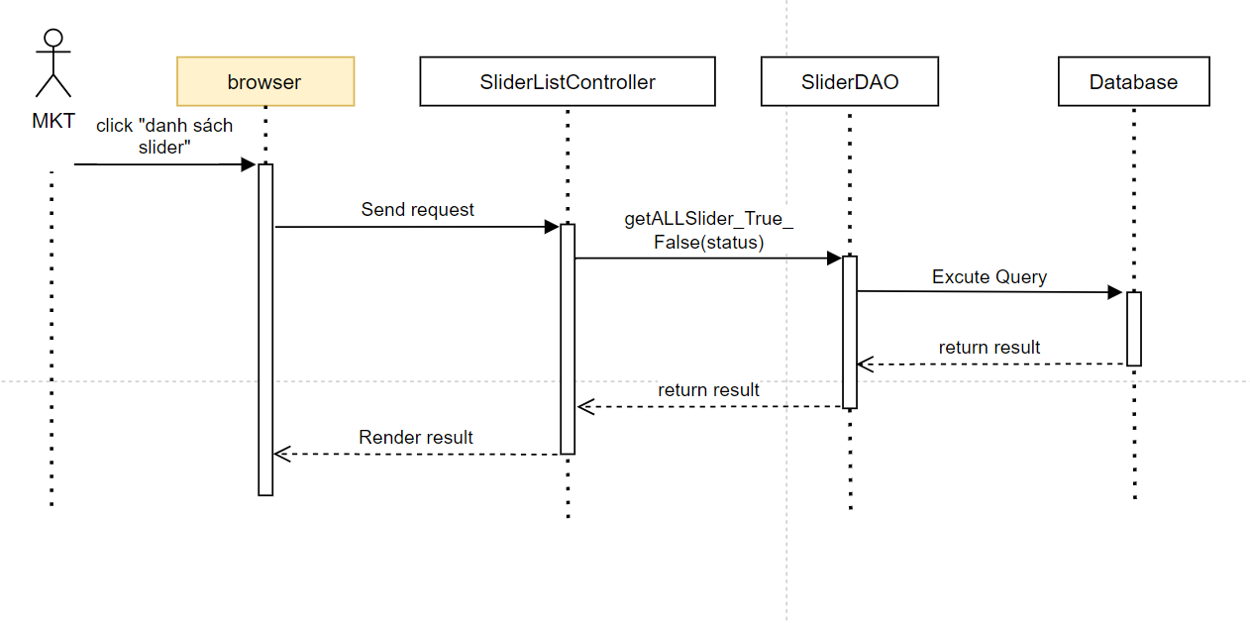

### d. Database queries

* "SELECT * FROM Slider where status " + status;

## 13.Public/CartDetail

## *a. Class Diagram*

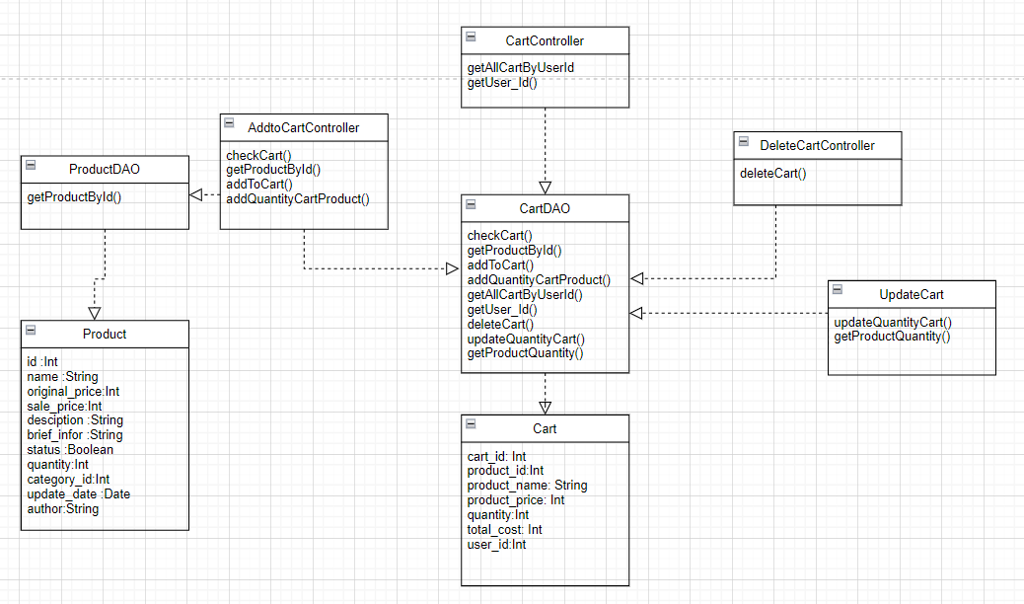

### b. Class Specifications

| **No** | **Method** | **Description** |
| --- | --- | --- |
| *01* | *checkCart()* | *check user and product exist* |
| *02* | *getProductById()* | *get product by id* |
| *03* | *addToCart()* | *Add product to cart* |
| *04* | *addQuantityCartProduct()* | *calculate total quantity and price when adding to cart* |
| *05* | *getAllCartByUserId()* | *get the products added to the cart by checking the user id* |
| *06* | *deleteCart()* | *remove products from cart* |
| *07* | *updateQuantityCart()* | *correct the number of products in the cart* |

### c. Sequence Diagram(s)

### 

### d. Database queries

* SELECT * FROM Cart WHERE user_id = ?
* SELECT * FROM Cart WHERE user_id = ? AND product_id = ?
* "INSERT INTO Cart (product_id, product_name, product_price, quantity, total_cost, user_id)"

+ " VALUES (?, ?, ?, ?, ?, ?)"

* UPDATE Cart"

+ " SET quantity = ?, total_cost = ?"

+ " WHERE product_id = ? AND user_id = ?

* DELETE FROM Cart"

+ " WHERE product_id = ? AND user_id = ?

* UPDATE Cart"

+ " SET quantity = ? "

+ " WHERE cart_id = ? AND product_id = ?

## 14.Public/Cart Contact

### a. Class Diagram

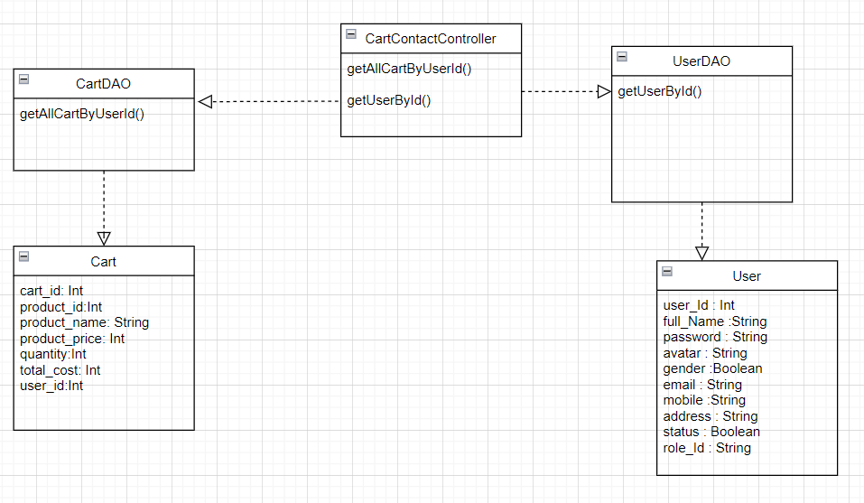

### b. Class Specifications

| **No** | **Method** | **Description** |
| --- | --- | --- |
| *01* | *getAllCartByUserId()* | *get the products added to the cart by checking the user id* |
| *02* | *getUserById()* | *get user info by checking user id* |

### c. Sequence Diagram(s)

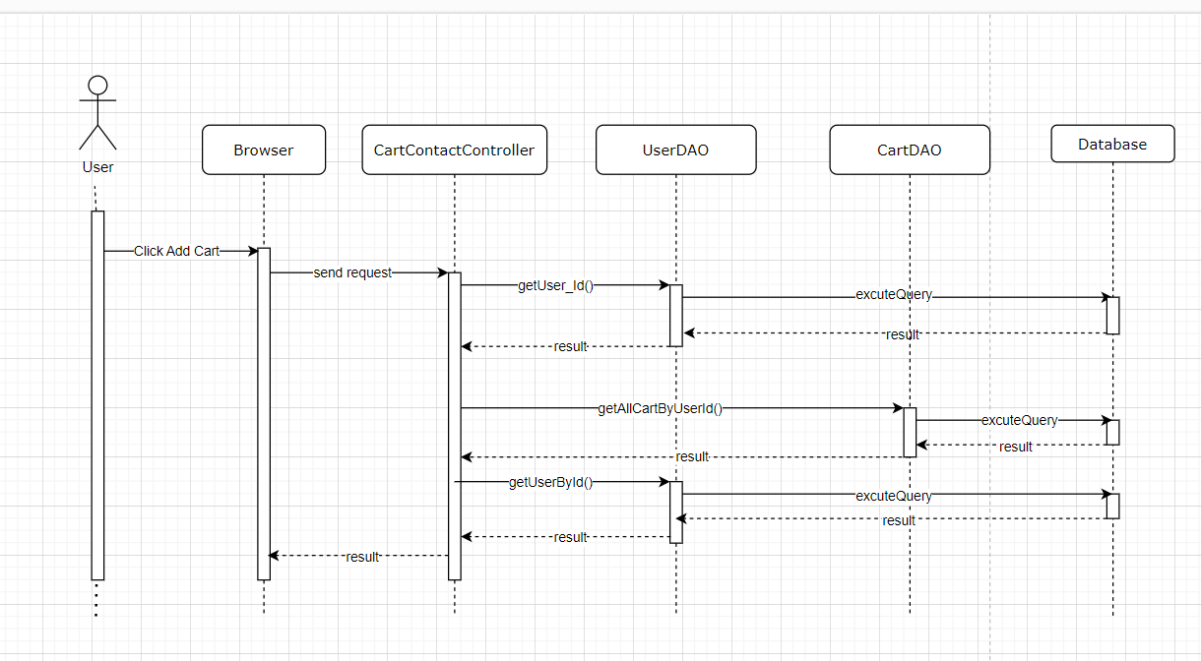

### d. Database queries

* SELECT * FROM Cart WHERE user_id = ?
* SELECT * FROM User WHERE userId = ?

## 15.My order

### a. Class Diagram

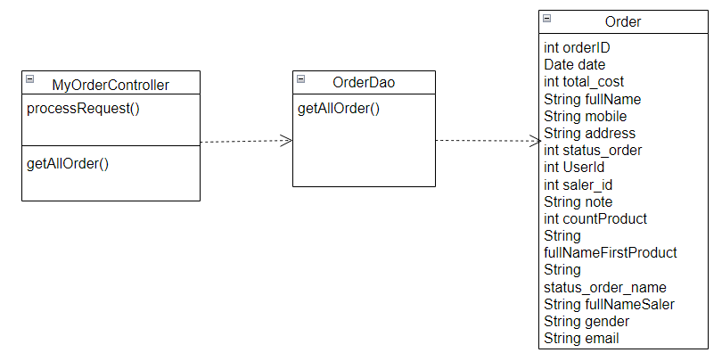

### b. Class Specifications

| **No** | **Method** | **Description** |
| --- | --- | --- |
| *01* | *getAllOrder()* | *Get all Order and status_order in database* |

### c. Sequence Diagram(s)

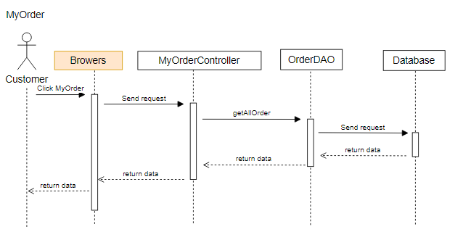

### d. Database queries

* "SELECT *\n"

+ "FROM `Order`\n"

+ "JOIN Status_Order ON `Order`.status_order = Status_Order.status_order_id\n"

+ "WHERE userId = ?";

## 16.Order Information

### a. Class Diagram

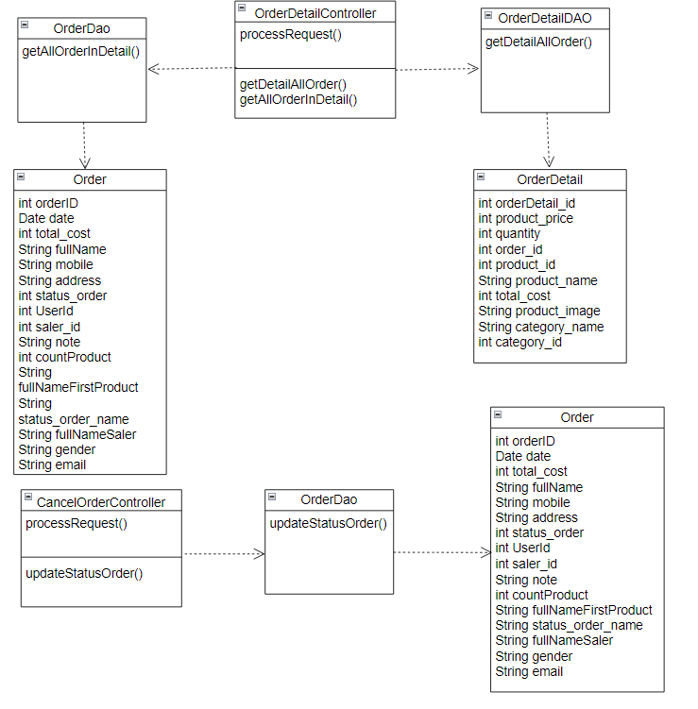

### b. Class Specifications

| **No** | **Method** | **Description** |
| --- | --- | --- |
| *01* | *getDetailAllOrder()* | *Get all Order_Detail ,Product ,Category,Products_Images in database* |
| *02* | *getAllOrderInDetail()* | *Get all Orders and status_order and part user in database* |
| *03* | *updateStatusOrder()* | *update Status Order* |

### c. Sequence Diagram(s)

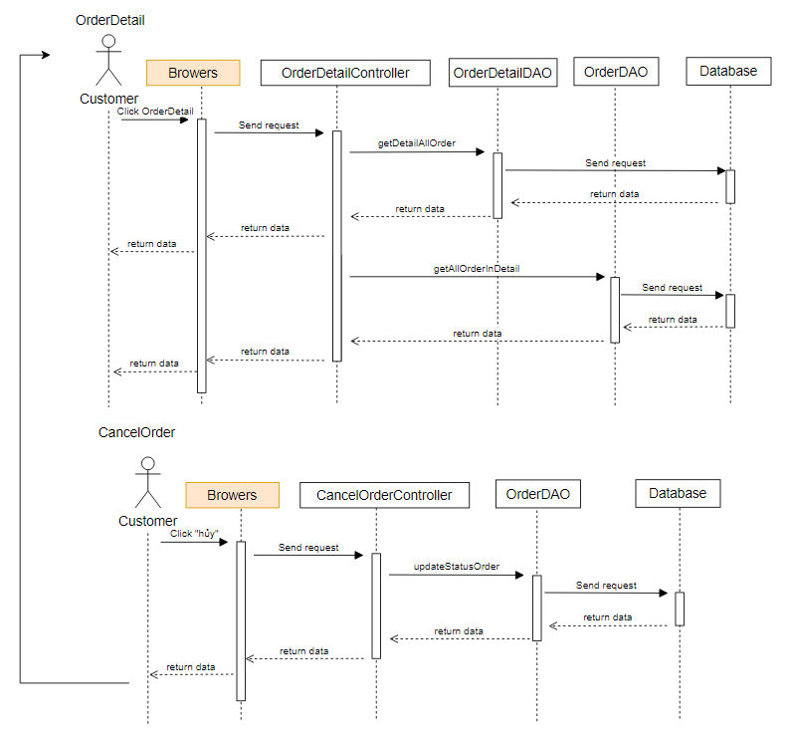

### d. Database queries

* String sql = "SELECT COUNT(*)\n"

+ "FROM Order_Detail\n"

+ "JOIN Product ON Order_Detail.product_id = Product.product_id\n"

+ "WHERE order_id = ?";

* String sql = "SELECT Product.product_name\n"

+ "FROM Order_Detail\n"

+ "JOIN Product ON Order_Detail.product_id = Product.product_id\n"

+ "WHERE order_id = ?\n"

+ "LIMIT 1";

* SELECT * FROM books_shop_online.Order_Detail \n"

+ "JOIN books_shop_online.Product ON Order_Detail.product_id = Product.product_id\n"

+ "JOIN books_shop_online.Products_Images ON Order_Detail.product_id = Products_Images.product_id\n"

+ "JOIN books_shop_online.Category ON Product.category_id = Category.category_id\n"

+ "WHERE order_id = ?;

* String sql = "SELECT *FROM books_shop_online.Order\n"

+ " JOIN books_shop_online.Status_Order ON books_shop_online.Order.status_order = books_shop_online.Status_Order.status_order_id\n"

+ " join books_shop_online.user on books_shop_online.Order.userId=books_shop_online.user.userId\n"

+ " WHERE order_id = ?";

## 17.Public/BlogDetail

### a. Class Diagram

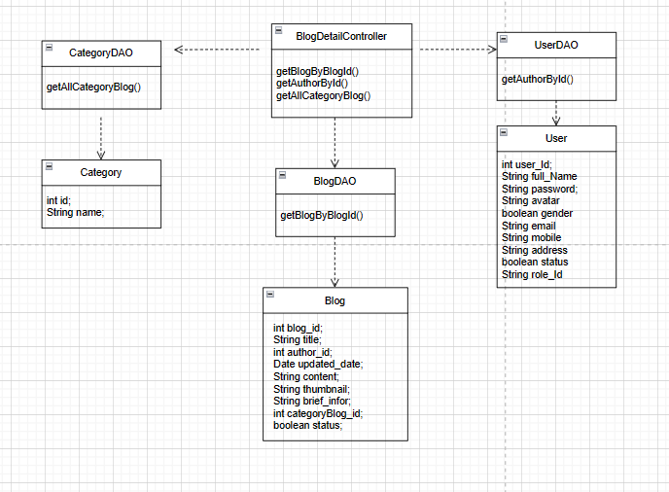

### b. Class Specifications

| **No** | **Method** | **Description** |
| --- | --- | --- |
| *01* | *getBlogByBlogId()* | *Get the Blog of by IIdd* |
| *02* | *getAuthorById()* | *Get all Author in database* |
| *03* | *getAllCategoryBlog()* | *Get all category in database* |

### c. Sequence Diagram(s)

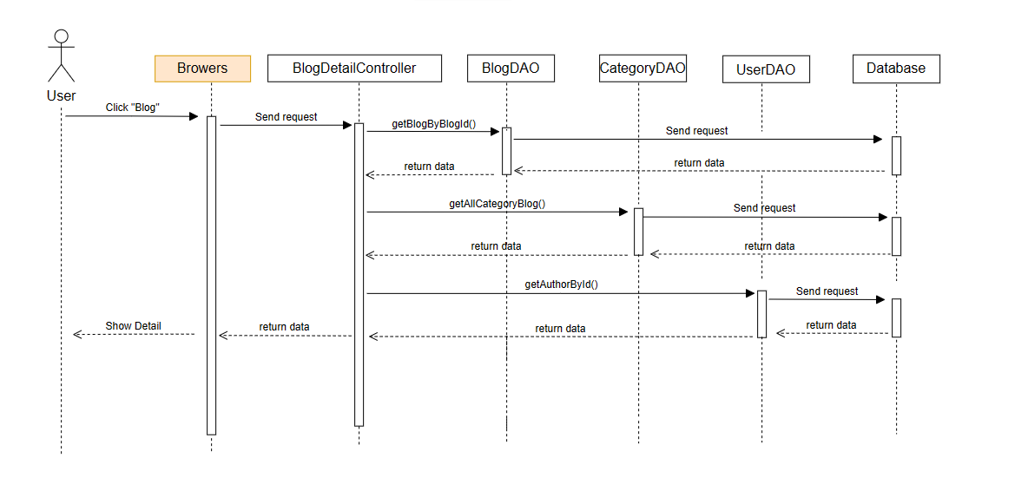

### d. Database queries

* Select * from books_shop_online.blog \n"
* + "where blog_id = ?
* Select * from books_shop_online.category_blog where status = 1
* select * from books_shop_online.User where userId = ?

## 18.Marketing/MKT Dashboard

### a. Class Diagram

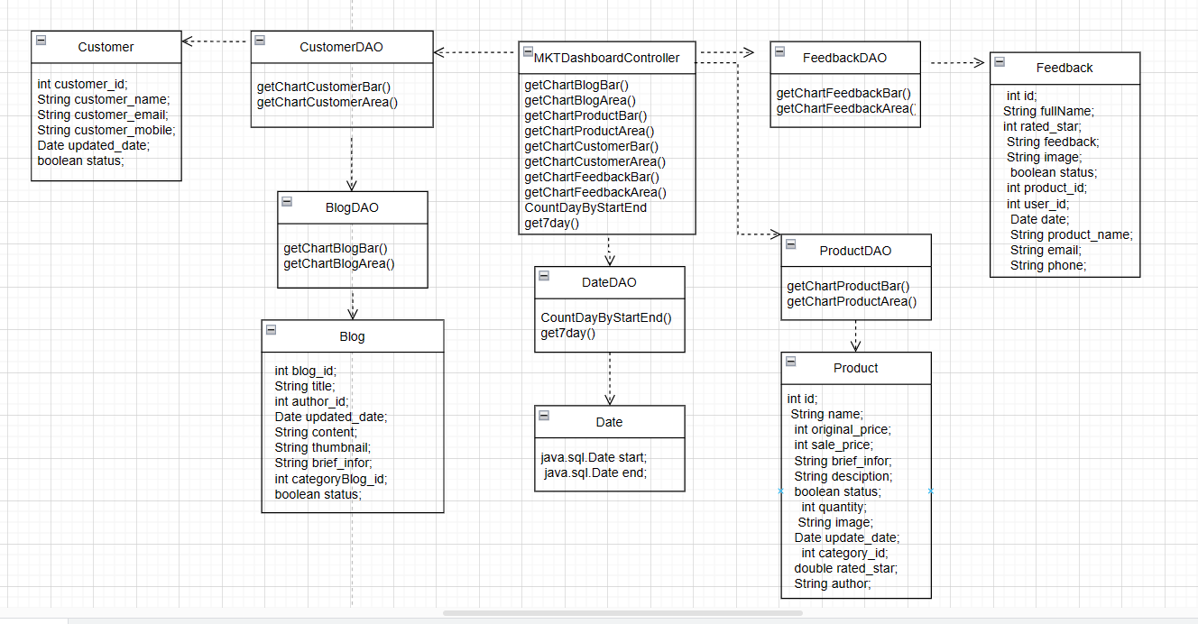

### b. Class Specifications

| **No** | **Method** | **Description** |
| --- | --- | --- |
| *01* | *getChartBlogBar()* | *get chart blog bar* |
| *02* | *getChartBlogArea()* | *get chart blog area* |
| *03* | *getChartProductBar()* | *get Chart Product Bar* |
| *04* | *getChartProductArea()* | *get Chart Product Area* |
| *05* | *get7day()* | *get 7 day* |
| *06* | *CountDayByStartEnd()* | *Count Day By Start End* |
| *07* | *getChartCustomerBar()* | *get Chart Customer Bar* |
| *08* | *getChartCustomerArea()* | *get Chart Customer Area* |
| *09* | *getChartFeedbackBar()* | *get Chart Feedback Bar* |
| *10* | *getChartFeedbackArea()* | *get Chart Feedback Area* |

### c. Sequence Diagram(s)

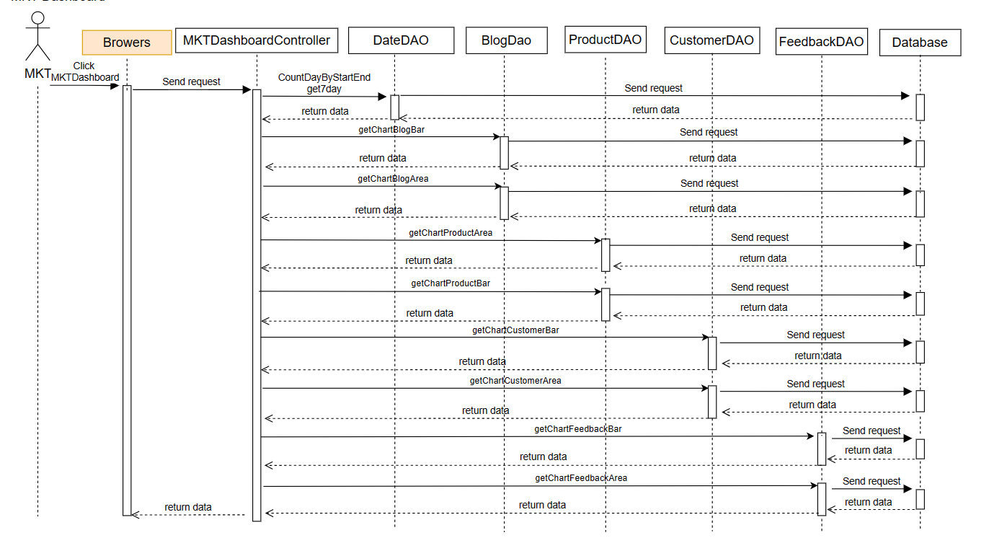

### d. Database queries

SELECT COUNT(*) FROM books_shop_online.Blog WHERE updated_date = DATE_ADD(?, INTERVAL ? DAY)AND status = 1;

SELECT COUNT(*) FROM Blog WHERE updated_date <= DATE_ADD(?, INTERVAL ? DAY) AND status = 1;

SELECT COUNT(*) FROM books_shop_online.product WHERE update_date = DATE_ADD(?, INTERVAL ? DAY ) AND status = 1;

SELECT COUNT(*) FROM product WHERE update_date <= DATE_ADD(?, INTERVAL ? DAY) AND status = 1;

SELECT COUNT(*) FROM books_shop_online.customer WHERE updated_date = DATE_ADD(?, INTERVAL ? DAY)

SELECT COUNT(*) FROM books_shop_online.customer WHERE updated_date <= DATE_ADD(?, INTERVAL ? DAY)

SELECT COUNT(*) FROM Feedback WHERE `date` = DATE_ADD(?, INTERVAL ? DAY) AND `status` = 1;

SELECT COUNT(*) FROM Feedback WHERE `date` <= DATE_ADD(?, INTERVAL ? DAY) AND `status` = 1;

SELECT CURRENT_TIMESTAMP, DATE_SUB(CURRENT_TIMESTAMP, INTERVAL 6 DAY);

SELECT DATEDIFF(DATE(?), DATE(?));

## 19.Marketing/MKT Product Detail

### a. Class Diagram

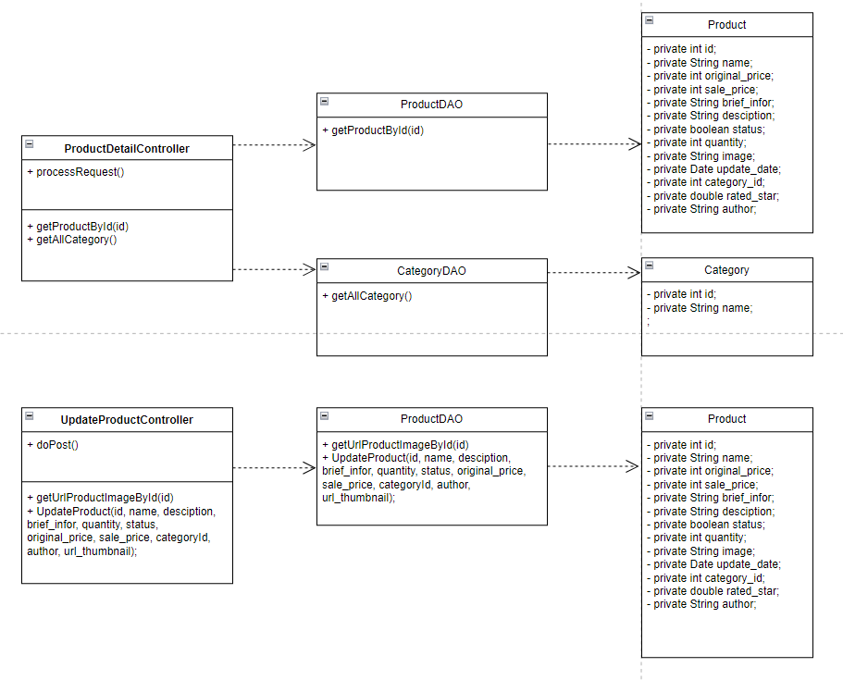

### b. Class Specifications

| **No** | **Method** | **Description** |
| --- | --- | --- |
| *01* | *getProductById()* | *get detail Product to the screen* |
| *02* | *getAllCategory()* | *get all category show to the screen* |
| *03* | *getUrlProductImageById()* | *get url of product image show to the screen* |
| *04* | *UpdateProduct()* | *update the detail of product show to the screen* |

### c. Sequence Diagram(s)

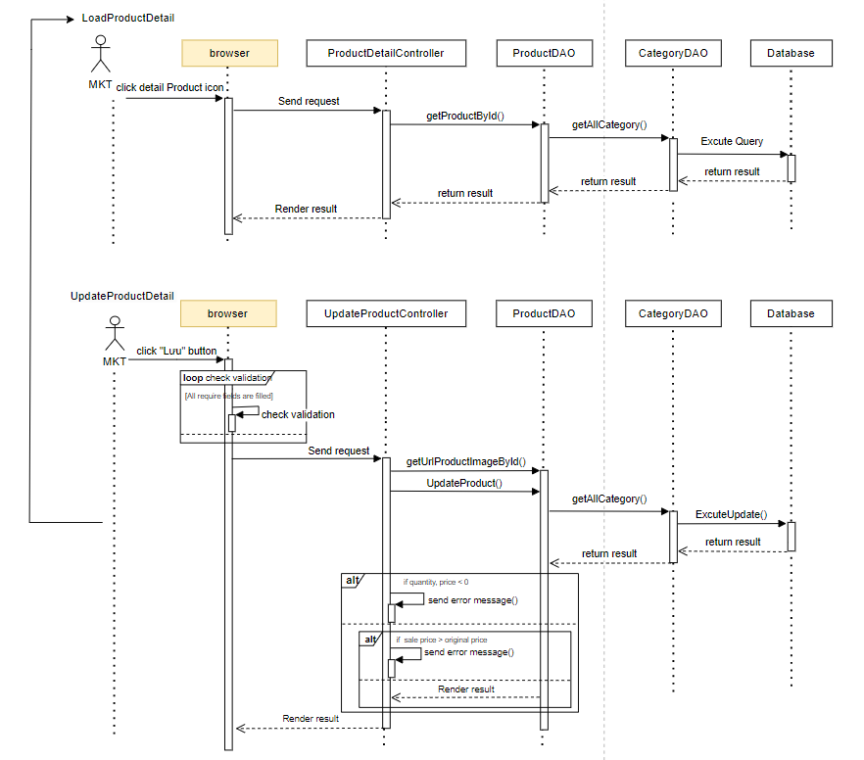

### d. Database queries

- select * from Product where product_id = ?

- Select * from books_shop_online.category where status = 1

- SELECT images FROM Products_Images where product_id = ?

- UPDATE Product\n"

+ " SET `product_name` = ?\n"

+ " ,`original_prices` = ?\n"

+ " ,`sale_prices` = ?\n"

+ " ,`product_details` = ?\n"

+ " ,`brief_infor` = ?\n"

+ " ,`status` = ?\n"

+ " ,`quantity` = ?\n"

+ " ,`category_id` = ?\n"

+ " ,`author` = ?\n"

+ " ,`update_date` = NOW()\n"

+ " WHERE `product_id` = ?

## 20.Marketing/MKT Slider Detail

### a. Class Diagram

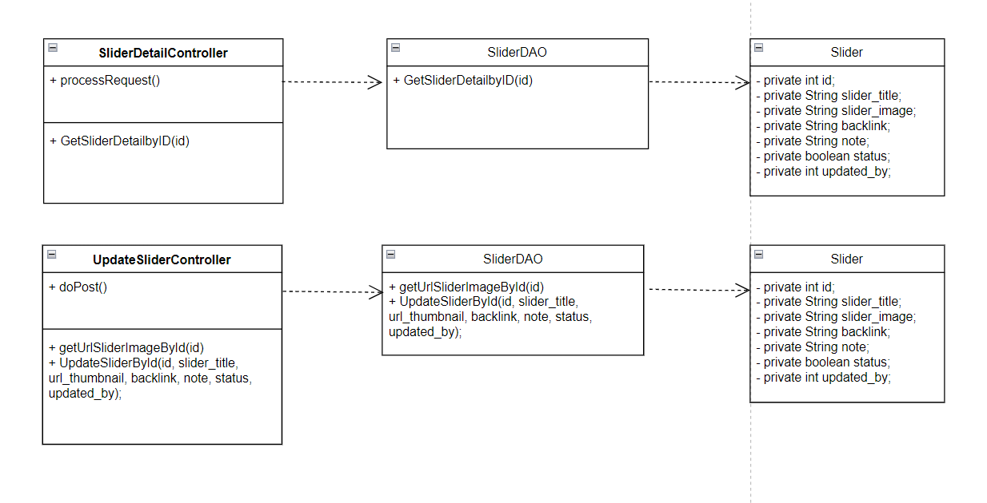

### b. Class Specifications

| **No** | **Method** | **Description** |
| --- | --- | --- |
| *01* | *GetSliderDetailbyID()* | *get detail Slider to the screen* |
| *02* | *getUrlSliderImageById()* | *get url of slider image show to the screen* |
| *03* | *UpdateSliderById()* | *update the detail of slider show to the screen* |

### c. Sequence Diagram(s)

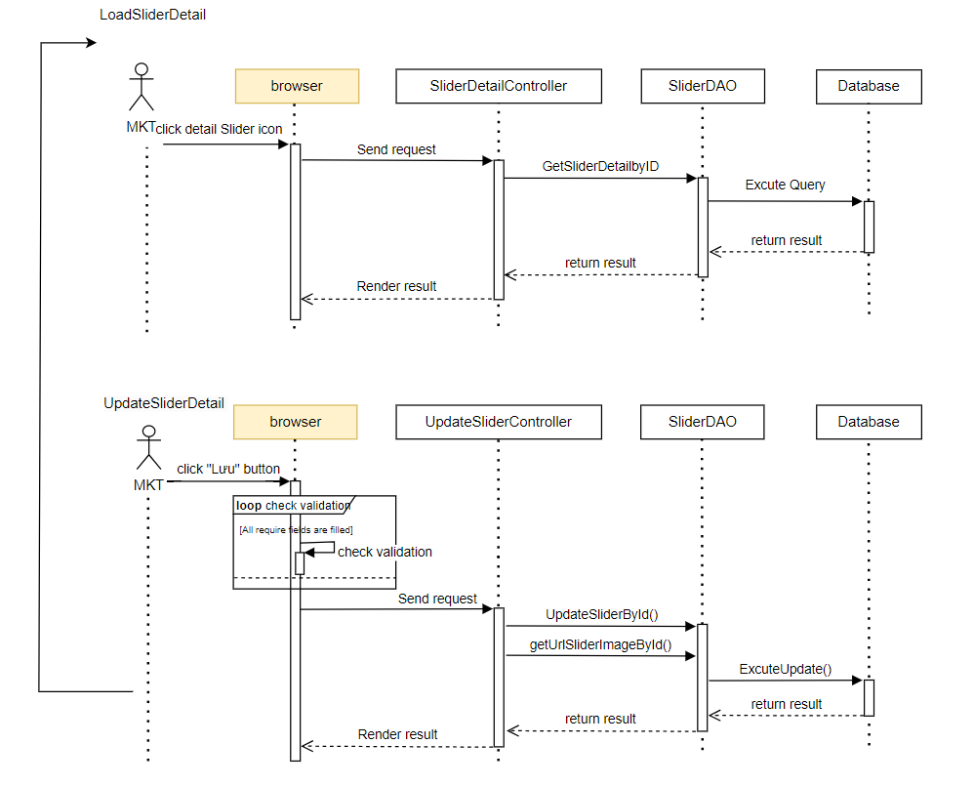

### d. Database queries

- SELECT * FROM Slider where slider_id = ?

- select slider_image from Slider where slider_id = ?

- UPDATE Slider\n"

+ " SET `slider_title` = ?\n"

+ " ,`slider_image` = ?\n"

+ " ,`backlink` = ?\n"

+ " ,`note` = ?\n"

+ " ,`status` = ?\n"

+ " ,`updated_by` = ? \n"

+ " WHERE `slider_id` = ?

## 21.Marketing/Posts List

### a. Class Diagram

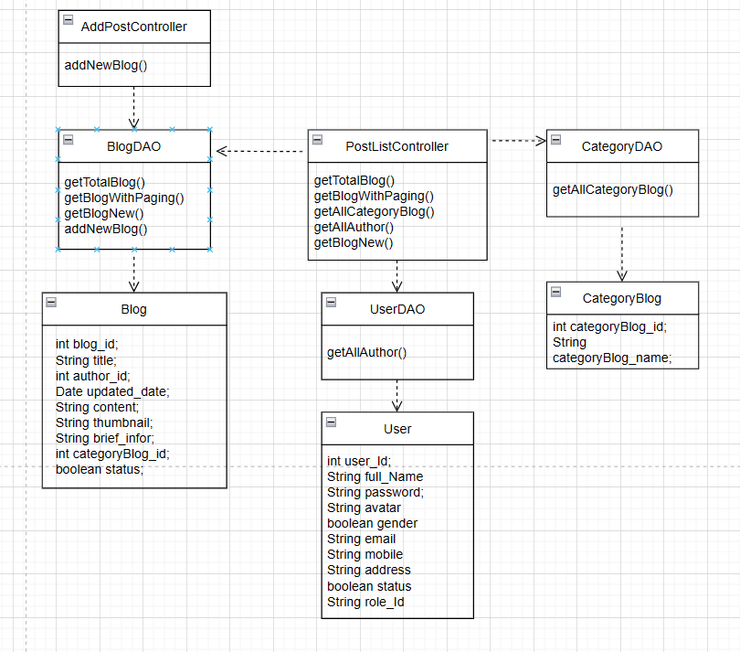

### b. Class Specifications

| **No** | **Method** | **Description** |
| --- | --- | --- |
| *01* | *getAllCategoryBlog()* | *get All Category Blog* |
| *02* | *getBlogWithPaging()* | *get Blog With Paging* |
| *03* | *getBlogNew()* | *Get blog new* |
| *04* | *getTotalBlog* | *get Total Blog* |
| *05* | *addNewBlog()* | *add New Blog* |
| *06* | *getAllAuthor()* | *get All Author* |

### c. Sequence Diagram(s)

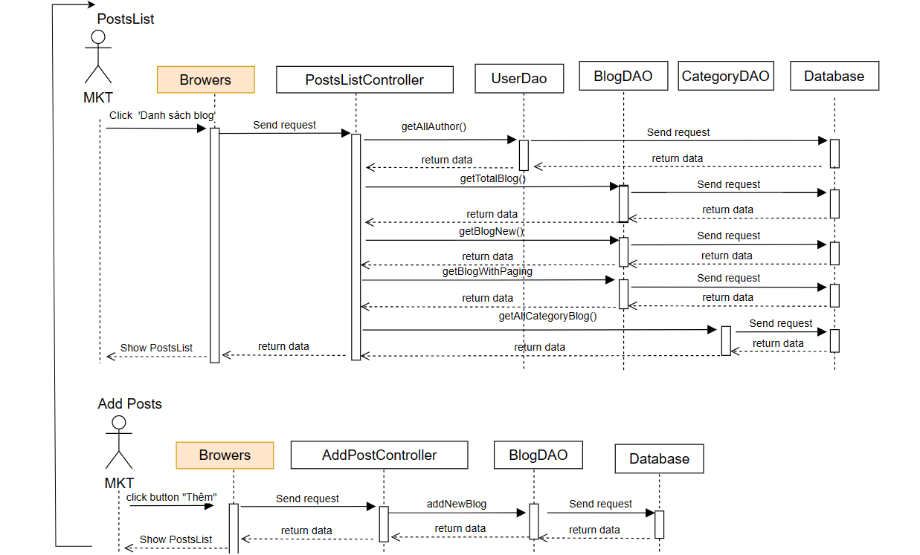

### d. Database queries

SELECT COUNT(blog_id) FROM blog\n"

+ "WHERE categoryBlog_id " + categoryId + " AND status " + status + " AND title LIKE '%" + searchKey + "%';

select * from books_shop_online.blog\n"

+ "where categoryBlog_id " + categoryId + " and status " + status + " and author_id " + authorId + " and title like N'%" + searchKey + "%'\n"

+ " order by " + value + " " + type + " LIMIT ?, ?;

Select * from books_shop_online.category_blog where status = 1

select * from User where role_id = 2  
SELECT *\n"

+ "FROM books_shop_online.blog\n"

+ "WHERE status = 1\n"

+ "ORDER BY updated_date DESC\n"

+ "LIMIT 1;

INSERT INTO Blog\n"

+ " (title\n"

+ " ,author_id\n"

+ " ,content\n"

+ " ,thumbnail\n"

+ " ,brief_infor\n"

+ " ,categoryBlog_id\n"

+ " ,status)\n"

+ " VALUES\n"

+ " (?,?,?,?,?,?,?)

## 22.Marketing/Posts Detail

### a. Class Diagram

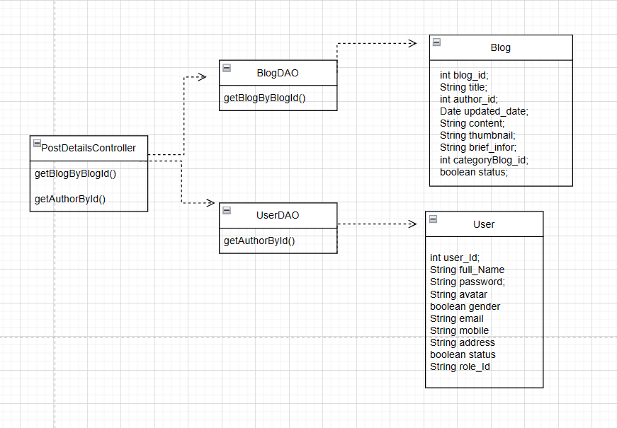

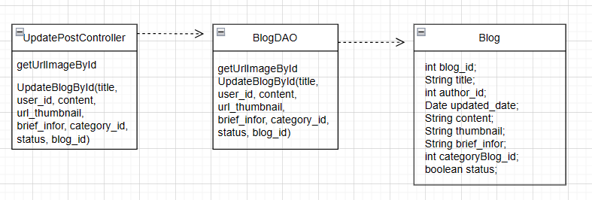

### b. Class Specifications

| **No** | **Method** | **Description** |
| --- | --- | --- |
| *01* | *getBlogByBlogId()* | *get Blog By Blog Id* |
| *02* | *getAuthorById()* | *get Author By Id* |
| *03* | *getUrlImageById()* | *get url of blog image show to the screen* |
| *04* | *UpdateBlogById()* | *update the detail of blog show to the screen* |

### c. Sequence Diagram(s)

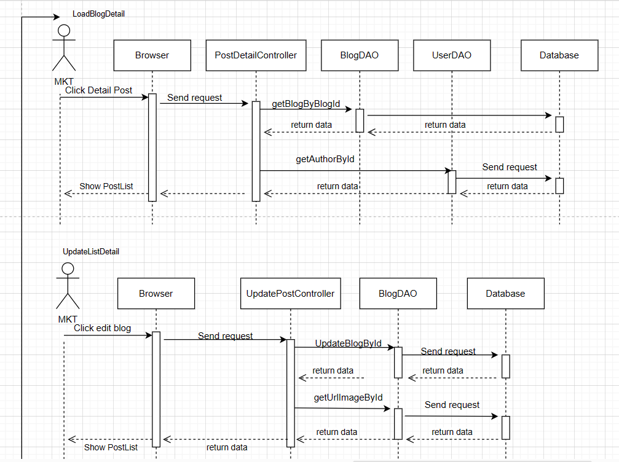

### d. Database queries

Select * from books_shop_online.blog \n"

+ "where blog_id = ?

select * from books_shop_online.User where userId = ?

UPDATE Blog\n"

+ "SET title = ?,\n"

+ " author_id = ?,\n"

+ " updated_date = CURRENT_TIMESTAMP,\n"

+ " content = ?,\n"

+ " thumbnail = ?,\n"

+ " brief_infor = ?,\n"

+ " categoryBlog_id = ?,\n"

+ " status = ?\n"

+ "WHERE blog_id = ?

select thumbnail from books_shop_online.blog where blog_id = ?

## 23.Sale/Sale Dashboard

### a. Class Diagram

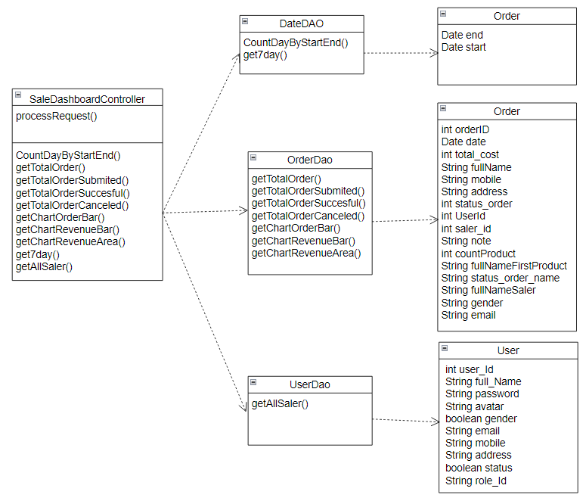

### b. Class Specifications

| **No** | **Method** | **Description** |
| --- | --- | --- |
| *01* | *CountDayByStartEnd()* | *Count Day By Start End* |
| *02* | *getTotalOrder()* | *get Total Order* |
| *03* | *getTotalOrderSubmited()* | *get Total Order Submitted* |
| *04* | *getTotalOrderSuccesful()* | *get Total Order Successful* |
| *05* | *getTotalOrderCanceled()* | *get Total Order Canceled* |
| *06* | *getChartOrderBar()* | *get Chart Order Bar* |
| *07* | *getChartRevenueBar()* | *get Chart Revenue Bar* |
| *08* | *getChartRevenueArea()* | *get Chart Revenue Area* |
| *09* | *get7day()* | *get 7 day* |
| *10* | *getAllSaler()* | *get All Saler* |

### c. Sequence Diagram(s)

### d. Database queries

- SELECT DATEDIFF(DATE(?), DATE(?));

- SELECT CURRENT_TIMESTAMP, DATE_SUB(CURRENT_TIMESTAMP, INTERVAL 6 DAY);

- SELECT COUNT(*) FROM `Order` \n"

+ "WHERE saler_id " + salerId + " AND orderDate <= ? AND orderDate >= ?;

- SELECT COUNT(*) FROM `Order`\n"

+ "WHERE saler_id " + salerId + " AND orderDate <= ? AND orderDate >= ? AND status_order =1;

- SELECT COUNT(*) FROM `Order`\n"

+ "WHERE saler_id " + salerId + " AND orderDate <= ? AND orderDate >= ? AND status_order =2;

- SELECT COUNT(*) FROM `Order`\n"

+ "WHERE saler_id " + salerId + " AND orderDate <= ? AND orderDate >= ? AND status_order =3;

- SELECT COUNT(*) FROM `Order`\n"

+ "WHERE saler_id " + salerId + " AND orderDate = DATE_ADD(?, INTERVAL ? DAY);

- SELECT SUM(total_cost) FROM `Order`\n"

+ "WHERE saler_id " + salerId + " AND orderDate = DATE_ADD(?, INTERVAL ? DAY);

- SELECT SUM(total_cost) FROM `Order`\n"

+ "WHERE saler_id " + salerId + " AND orderDate <= DATE_ADD(?, INTERVAL ? DAY) AND orderDate >= ?;

- SELECT * FROM `User` WHERE role_id = 3;

## 24.Sale/Orders Details

### a. Class Diagram

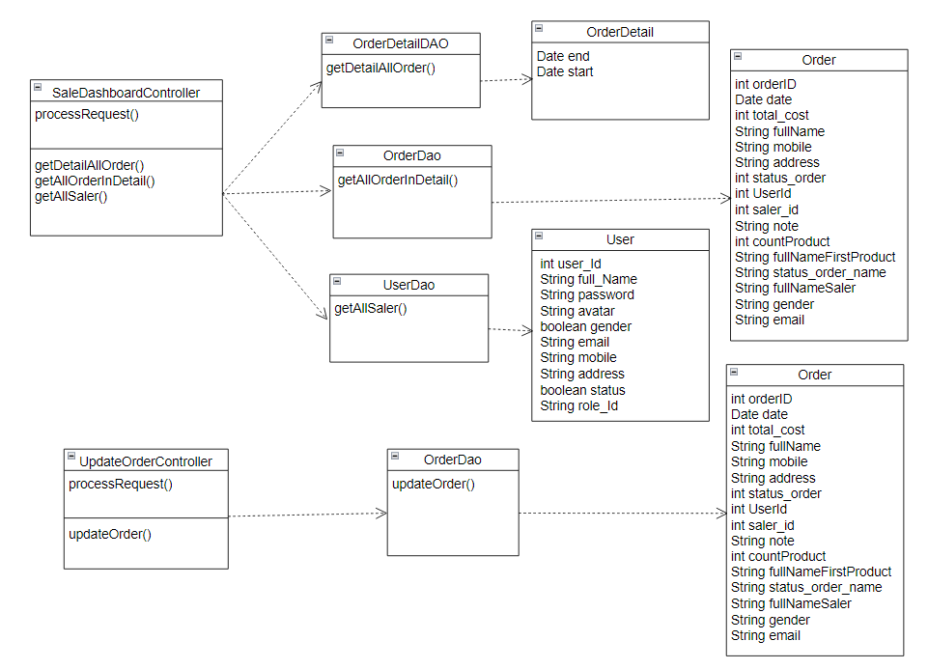

### b. Class Specifications

| **No** | **Method** | **Description** |
| --- | --- | --- |
| *01* | *getDetailAllOrder()* | *get Detail All Order* |
| *02* | *getAllOrderInDetail()* | *get All Order In Detail* |
| *03* | *getAllSaler()* | *get All Saler* |
| *04* | *updateOrder()* | *update Order* |

### c. Sequence Diagram(s)

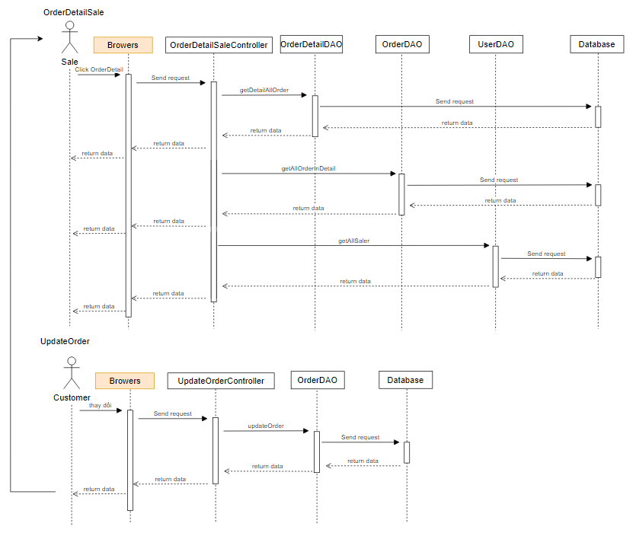

### d. Database queries

- SELECT *\n"

+ "FROM books_shop_online.Order_Detail\n"

+ "JOIN books_shop_online.Product ON books_shop_online.Order_Detail.product_id = books_shop_online.Product.product_id\n"

+ "JOIN books_shop_online.Products_Images ON books_shop_online.Order_Detail.product_id = books_shop_online.Products_Images.product_id\n"

+ "JOIN books_shop_online.Category ON books_shop_online.Product.category_id = books_shop_online.Category.category_id\n"

+ "WHERE books_shop_online.Order_Detail.order_id = ?

- SELECT *FROM books_shop_online.Order\n"

+ " JOIN books_shop_online.Status_Order ON books_shop_online.Order.status_order = books_shop_online.Status_Order.status_order_id\n"

+ " join books_shop_online.user on books_shop_online.Order.userId=books_shop_online.user.userId\n"

+ " WHERE order_id = ?

- SELECT COUNT(*)\n"

+ "FROM Order_Detail\n"

+ "JOIN Product ON Order_Detail.product_id = Product.product_id\n"

+ "WHERE order_id = ?

- SELECT Product.product_name\n"

+ "FROM Order_Detail\n"

+ "JOIN Product ON Order_Detail.product_id = Product.product_id\n"

+ "WHERE order_id = ?\n"

+ "LIMIT 1

- SELECT * FROM `User` WHERE role_id = 3;

- "UPDATE `Order`\n"

+ "SET `status_order` = ?, `saler_id` = ?,`note` = ?\n"

+ "WHERE `order_id` = ?; "

## 25.Sale/Order List

### a. Class Diagram

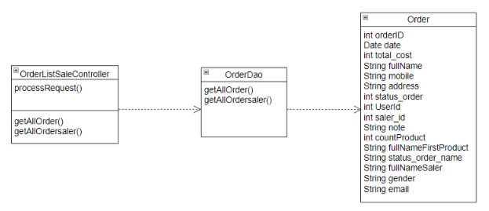

### b. Class Specifications

| **No** | **Method** | **Description** |
| --- | --- | --- |
| *01* | *getAllOrder()* | *get All Order* |
| *02* | *getAllOrdersaler()* | *get All Order according to seller* |

### c. Sequence Diagram(s)

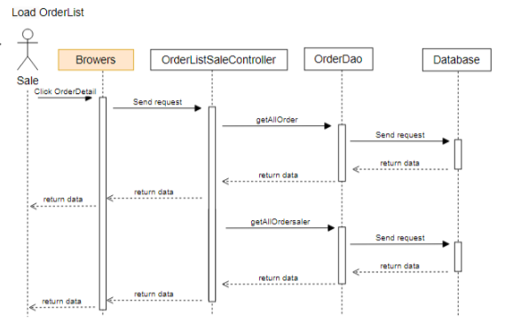

### d. Database queries

- SELECT * FROM `Order`\n"

+ "JOIN Status_Order ON `Order`.status_order = Status_Order.status_order_id\n"

+ "JOIN `User` ON `User`.userId = `Order`.saler_id;

- SELECT * FROM `Order`\n"

+ "JOIN Status_Order ON `Order`.status_order = Status_Order.status_order_id\n"

+ "JOIN `User` ON `User`.userId = `Order`.saler_id where saler_id=?;

## 26.Admin/User List

### a. Class Diagram

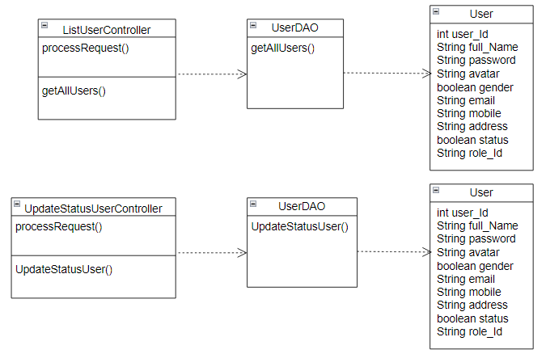

### b. Class Specifications

| **No** | **Method** | **Description** |
| --- | --- | --- |
| *01* | *getAllUsers()* | *get All Users* |
| *02* | *UpdateStatusUser()* | *Update Status User* |

### c. Sequence Diagram(s)

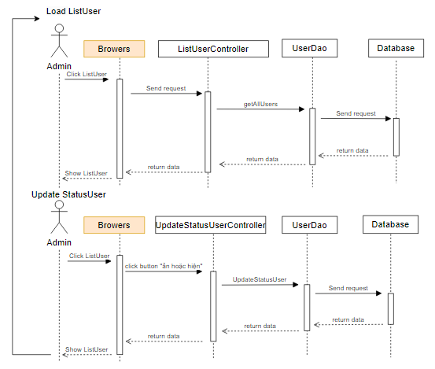

### d. Database queries

- "SELECT *\n"

+ "FROM `User`;"

- "UPDATE `User`\n"

+ "SET `status` = ?\n"

+ "WHERE `userId` = ?;"

## 

## 27.Admin/User Details

### a. Class Diagram

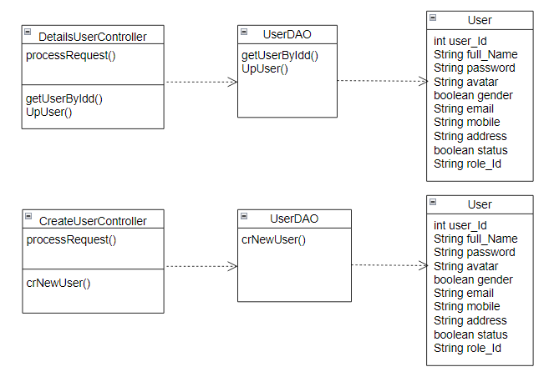

### b. Class Specifications

| **No** | **Method** | **Description** |
| --- | --- | --- |
| *01* | *getUserByIdd()* | *get User By Id* |
| *02* | *UpUser()* | *Update user* |
| *03* | *crNewUser()* | *Create New User* |

### c. Sequence Diagram(s)

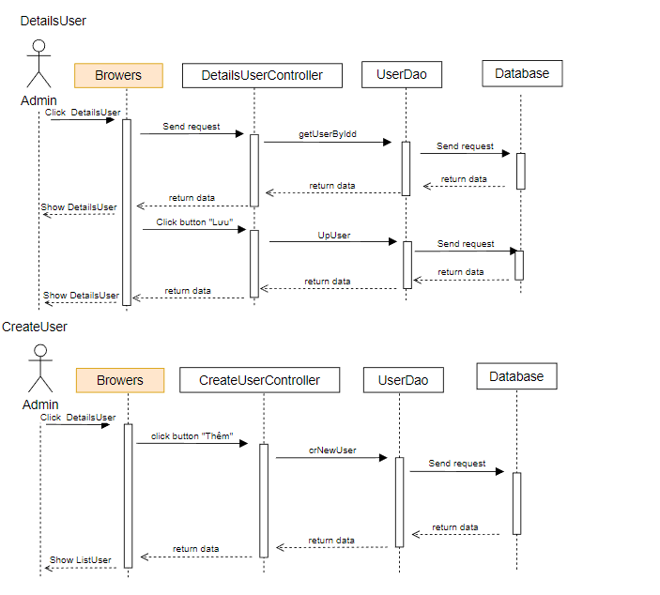

### d. Database queries

- "INSERT INTO `books_shop_online`.`user` (`fullName`, `password`, `gender`, `email`, `mobile`, `address`, `status`, `role_id`) VALUES (?,?,?,?,?,?,0,?);"

- "select * from books_shop_online.user where userId = ?"

- "UPDATE `books_shop_online`.`user`\n"

+ "SET `fullName` = ?,\n"

+ " `password` = ?,\n"

+ " `gender` = ?,\n"

+ " `email` = ?,\n"

+ " `mobile` = ?,\n"

+ " `address` = ?,\n"

+ " `status` = ?,\n"

+ " `role_id` = ?\n"

+ "WHERE `userId` = ?;"

## 28.Admin/Setting List

### a. Class Diagram

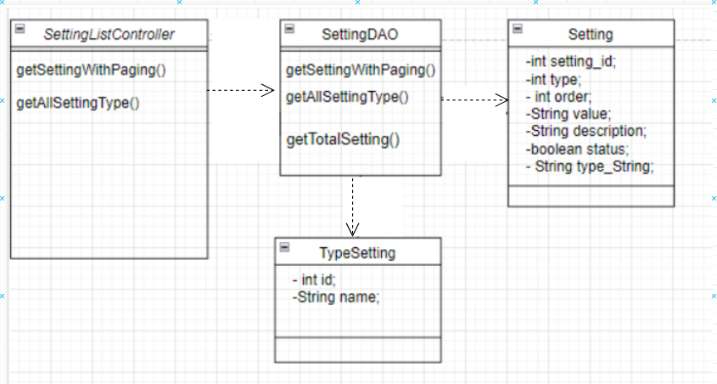

### 

### 

### b. Class Specifications

| **No** | **Method** | **Description** |
| --- | --- | --- |
| *01* | *getSettingWithPaging()* | *setting paging* |
| *02* | *getAllSettingType()* | *get all setting type* |
| *03* | *getTotalSetting()* | *count all setting follow keysearch input* |

### c. Sequence Diagram(s)

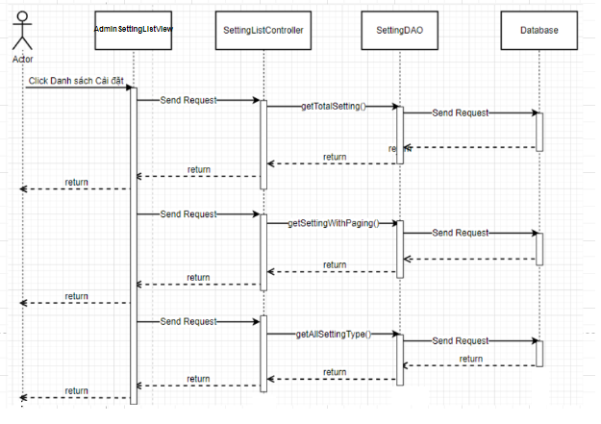

### d. Database queries

-SELECT * FROM `setting` where `type` " + typeId + " and `status` " + status + " and `value` like N'%" + searchKey + "%' order by " + value + " " + type + " LIMIT ?, ?;

-select * from setting_type

-SELECT COUNT(*) FROM `setting` where `type` " + typeId + " and `status` " + status + " and `value` like N'%" + searchKey + "%';

## 29.Admin/Setting Details

### a. Class Diagram

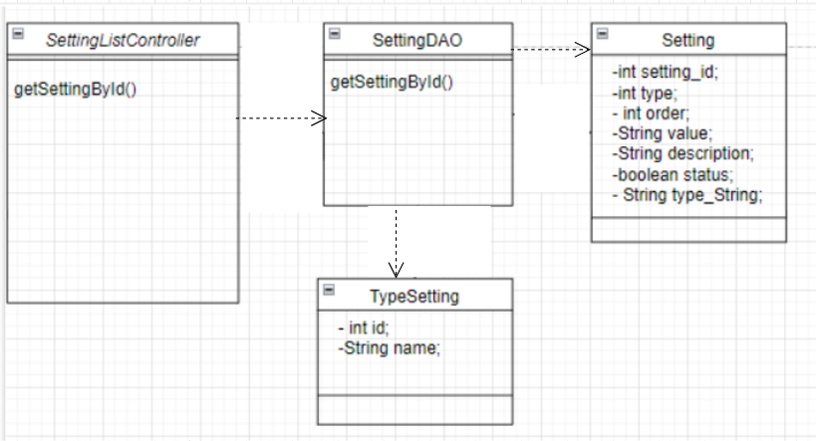

### b. Class Specifications

| **No** | **Method** | **Description** |
| --- | --- | --- |
| *01* | *getSettingById()* | *get setting by ID* |

### c. Sequence Diagram(s)

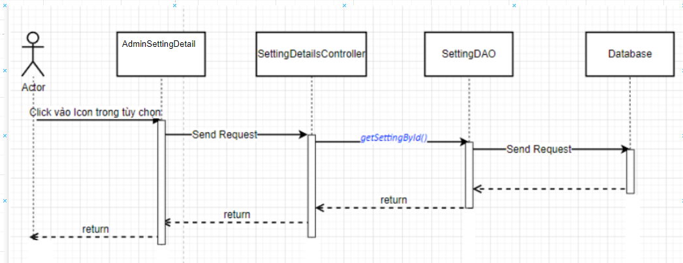

### d. Database queries

-select * from setting s join setting_type st on s.type = st.setting_type_id where setting_id = ?

## 30.Admin/Admin DashBoard

### a. Class Diagram

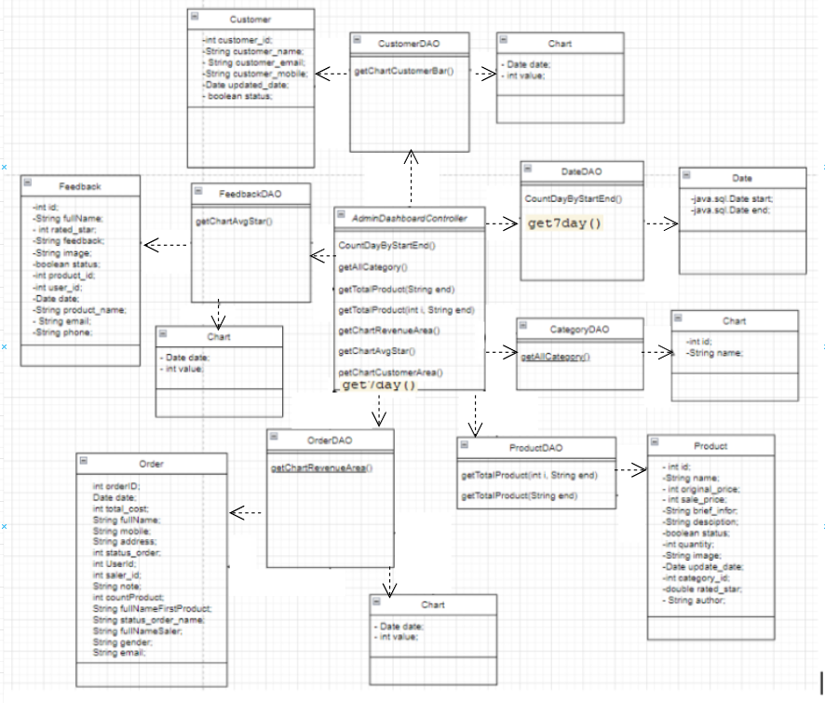

### b. Class Specifications

| **No** | **Method** | **Description** |
| --- | --- | --- |
| *01* | *CountDayByStartEnd()* | *calculate the number of days difference between two date values.* |
| *02* | *getAllCategory()* | *get all Category* |
| *03* | *getTotalProduct(String end)* | *count all product have update_date < ended* |
| *04* | *getTotalProduct(int i, String end)* | *count all product have update_date < ended with category_id* |
| *05* | *getChartRevenueArea()* | *calculate sum (total_cost)* |
| *06* | *getChartAvgStar()* | *average of values in rated_star column* |
| *07* | *getChartCustomerArea()* | *COUNT all Customer in condition date* |
| *08* | *get7day()* | *subtract 6 days from current time value* |

### c. Sequence Diagram(s)

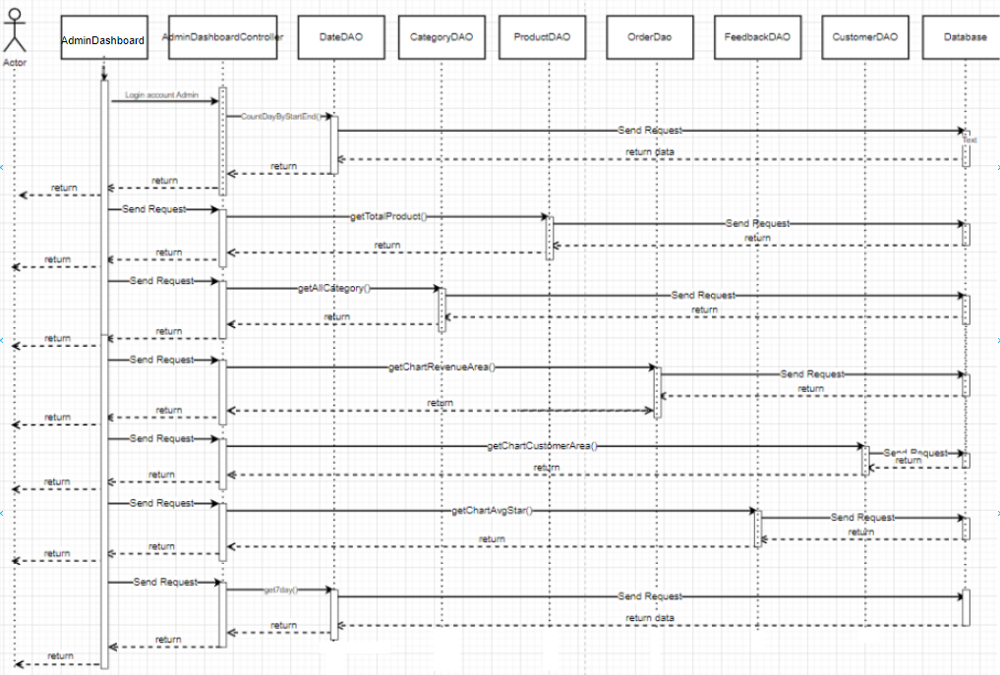

### d. Database queries

-SELECT DATEDIFF(DATE(?), DATE(?));

-select COUNT(*) from Product where update_date < ?;

-select COUNT(*) from Product where category_id = ? and update_date < ?;

-Select * from books_shop_online.category where status = 1

-select sum(total_cost) from `Order` where saler_id " + salerId + " and orderDate <= DATE_ADD(?, INTERVAL ? DAY) and orderDate >= ?;

-SELECT DATE_ADD(?, INTERVAL ? DAY);

-SELECT COUNT(*) FROM books_shop_online.customer WHERE updated_date <= DATE_ADD(?, INTERVAL ? DAY)

-SELECT CAST(AVG(rated_star) AS DECIMAL(10,1)) FROM Feedback WHERE date < DATE_ADD(?, INTERVAL ? DAY);

-SELECT CURRENT_TIMESTAMP, DATE_SUB(CURRENT_TIMESTAMP, INTERVAL 6 DAY);

## 31.Marketing/Feedback List

### a. Class Diagram

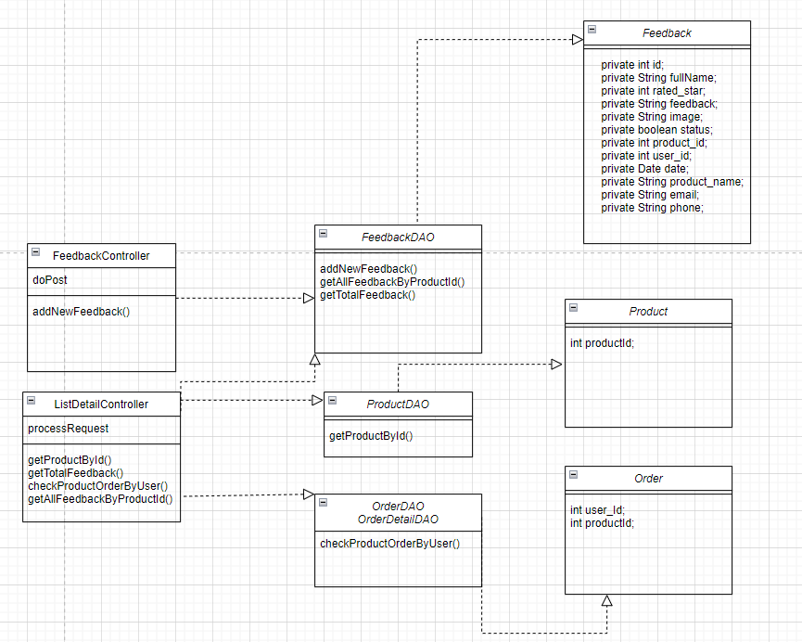

### b. Class Specifications

| **No** | **Method** | **Description** |
| --- | --- | --- |
| *01* | *getAllFeedback()* | *get list of user feedback* |
| *02* | *changeStatusFeedback()* | *change the status of user feedback* |

### c. Sequence Diagram(s)

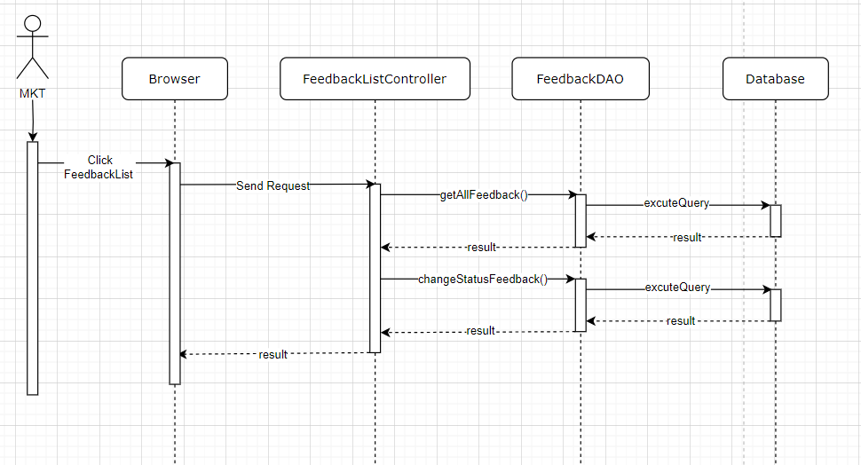

### d. Database queries

- SELECT f.*, p.product_name \n" +

"FROM Feedback f \n" +

"JOIN Product p ON f.product_id = p.product_id;

- UPDATE `Feedback` "

+ "SET `status` = ? "

+ "WHERE `feedBack_id` = ?

## 32.Marketing/Feedback Detail

### a. Class Diagram

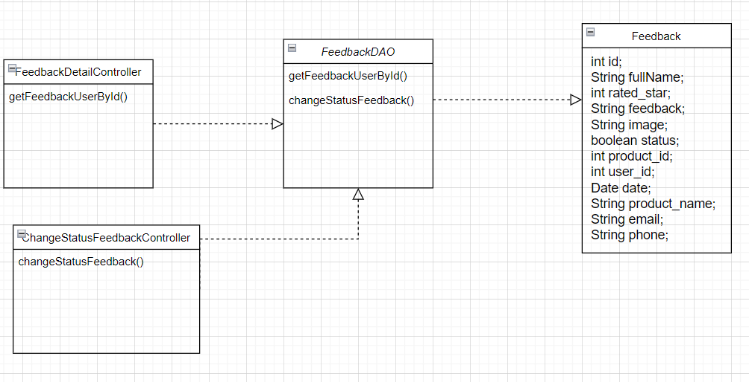

### b. Class Specifications

| **No** | **Method** | **Description** |
| --- | --- | --- |
| *01* | *getFeedbackUserById()* | *get user feedback by id* |
| *02* | *changeStatusFeedback()* | *change the status of user feedback* |

### 

### c. Sequence Diagram(s)

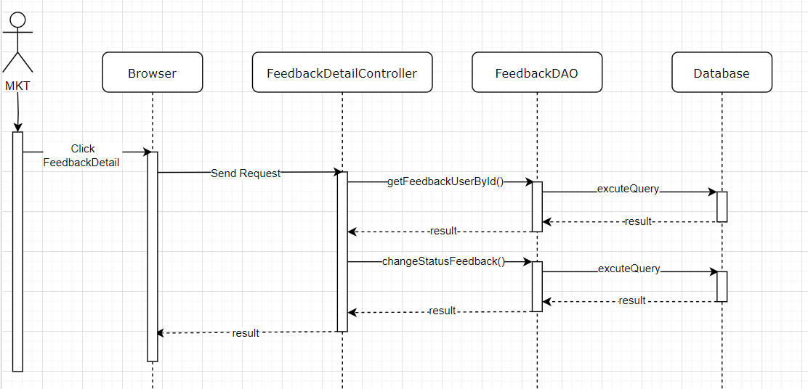

### d. Database queries

- SELECT f.*, p.product_name, u.email, u.mobile\n" +

"FROM Feedback f\n" +

"JOIN Product p ON f.product_id = p.product_id\n" +

"JOIN `User` u ON f.userId = u.userId\n" +

"WHERE f.feedback_id = ?;

- UPDATE `Feedback` "

+ "SET `status` = ? "

+ "WHERE `feedBack_id` = ?

## 33.Marketing/Customer List

### a. Class Diagram

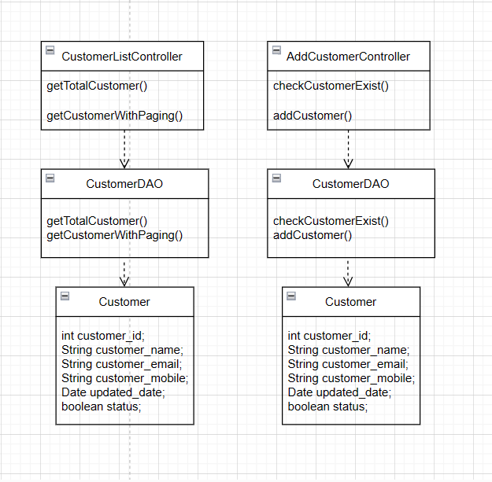

### b. Class Specifications

### 

| **No** | **Method** | **Description** |
| --- | --- | --- |
| *01* | *getTotalCustomer()* | *get Total Customer* |
| *02* | *getCustomerWithPaging()* | *get Customer With Paging* |
| *03* | *checkCustomerExist()* | *check Customer duplicate* |
| *04* | *addCustomer()* | *add new Customer* |

### 

### c. Sequence Diagram(s)

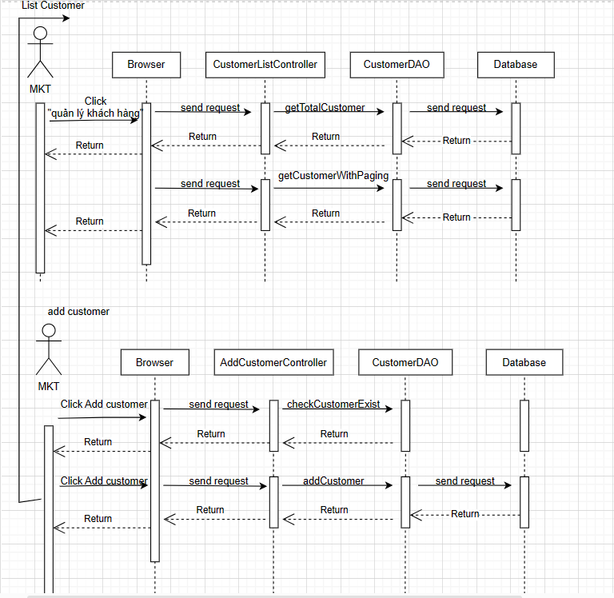

### d. Database queries

Select count(*) from books_shop_online.customer\n"

+ "where status " + status + " and customer_name like N'%" + searchKey + "%'

select * from Customer\n"

+ "where status " + status + " and customer_name like N'%" + searchKey + "%'\n"

+ " order by " + value + " " + type + " LIMIT ?, ?;

select * from books_shop_online.customer\n"

+ "where customer_email = ?

INSERT INTO customer (customer_name, customer_email, customer_mobile, updated_date, status) VALUES (?, ?, ?, CURRENT_TIMESTAMP, ?)

## 34.Marketing/Customer Detail

### a. Class Diagram

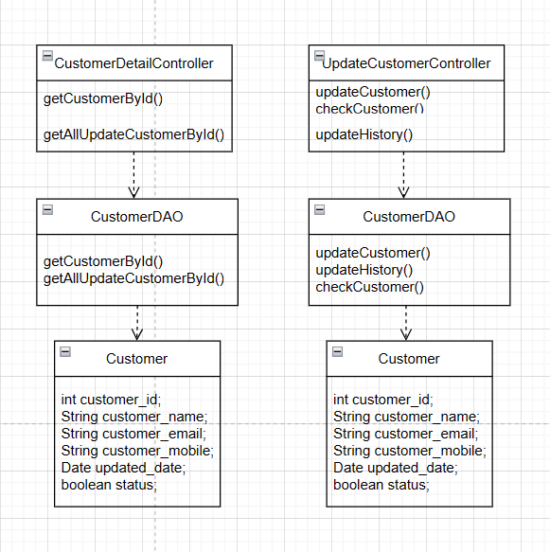

### b. Class Specifications

### 

| **No** | **Method** | **Description** |
| --- | --- | --- |
| *01* | *getCustomerById* | *getCustomerById* |
| *02* | *getAllUpdateCustomerById()* | *getAllUpdateCustomerById* |
| *03* | *checkCustomer()* | *check duplicate Customer* |
| *04* | *updateCustomer()* | *update Customer* |
| *05* | *updateHistory()* | *update History* |

### 

### c. Sequence Diagram(s)

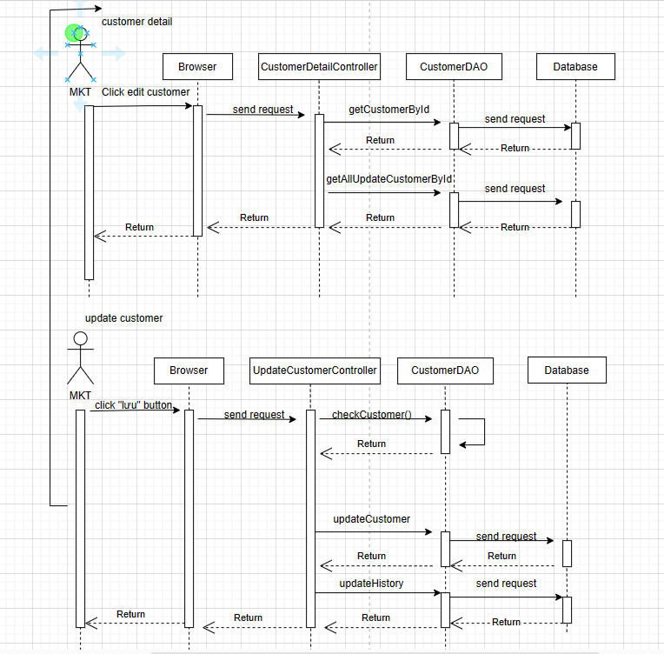

### d. Database queries

select * from customer\n"

+ "where customer_id = ?

SELECT uc.*, u.fullName\n"

+ "FROM Update_Customer uc\n"

+ "JOIN User u ON uc.update_by = u.userId\n"

+ "WHERE uc.customer_id = ?;

SELECT customer_id, customer_name, customer_email, customer_mobile\n"

+ "FROM Customer\n"

+ "WHERE (customer_email = ? AND customer_id != ?) OR (customer_mobile = ? AND customer_id != ?)

UPDATE customer\n"

+ "SET customer_name = ?,\n"

+ " customer_email = ?,\n"

+ " customer_mobile = ?,\n"

+ " updated_date = CURRENT_TIMESTAMP\n"

+ "WHERE customer_id = ?

INSERT INTO Update_Customer\n"

+ " (customer_id\n"

+ " ,email\n"

+ " ,fullName\n"

+ " ,mobile\n"

+ " ,update_by)\n"

+ " VALUES\n"

+ " (?,?,?,?,?)

## 

## 35. <Common/Authorization >

### a. Class Diagram

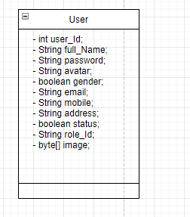

### b. Class Specifications

### 

| **No** | **Method** | **Description** |
| --- | --- | --- |

### 

### c. Sequence Diagram(s)

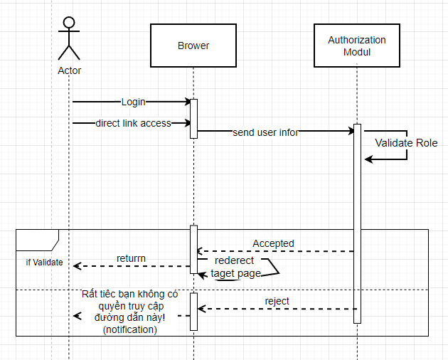

### d. Database queries

## 36.Public/CartCompletion

### a. Class Diagram

### 

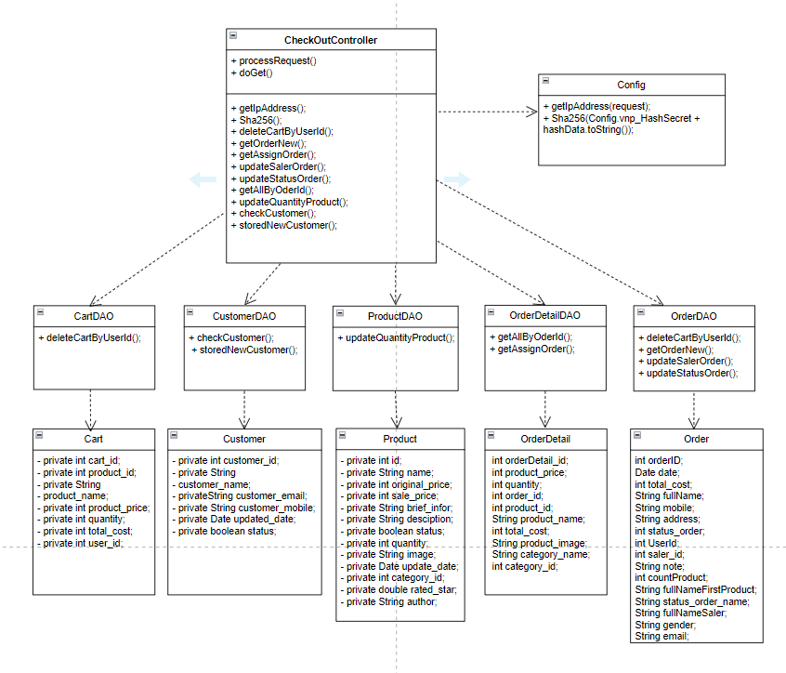

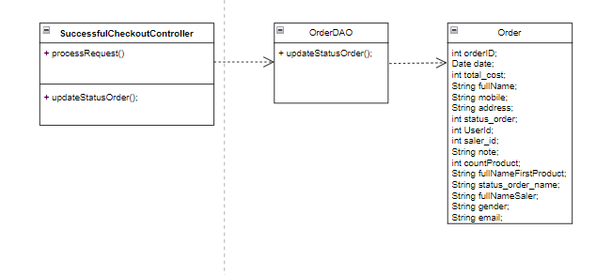

### b. Class Specifications

### 

| **No** | **Method** | **Description** |
| --- | --- | --- |
| *01* | *createNewOrder();* | *create New Order* |
| *02* | *getAllCartByUserId();* | *get All of Carts By User* |
| *03* | *addCartToOrder();* | *add Cart To User Order* |
| *04* | *getIpAddress();* | *get the Ip Address of user* |
| *05* | *Sha256();* | *compute the SHA-256 hash value of a given message.* |
| *06* | *deleteCartByUserId();* | *delete Cart By User* |
| *07* | *getOrderNew();* | *get the new Order* |
| *08* | *getAssignOrder();* | *get random saler for order* |
| *09* | *updateSalerOrder();* | *update Saler for Order* |
| *10* | *updateStatusOrder();* | *update Status for Order* |
| *11* | *getAllByOderId();* | *get All OderDetail by OrderId* |
| *12* | *updateQuantityProduct();* | *update Quantity of Product* |
| *13* | *checkCustomer();* | *check Customer exist* |
| *14* | *storedNewCustomer();* | *stored a New Customer* |

### c. Sequence Diagram(s)

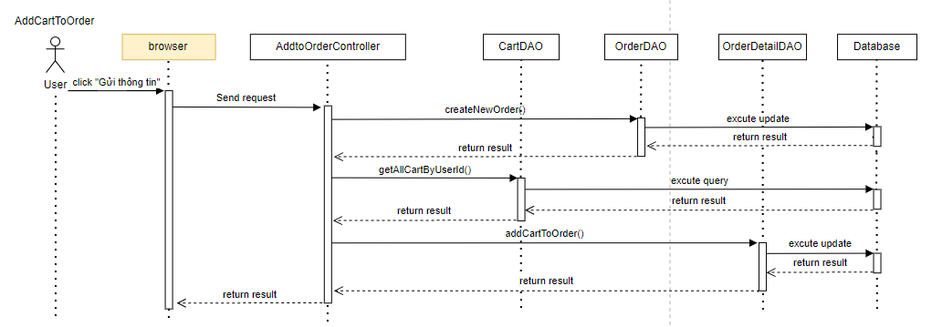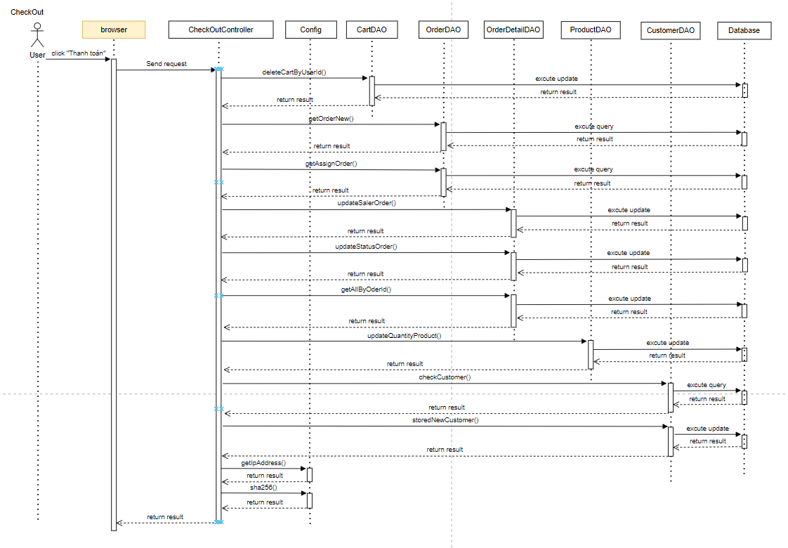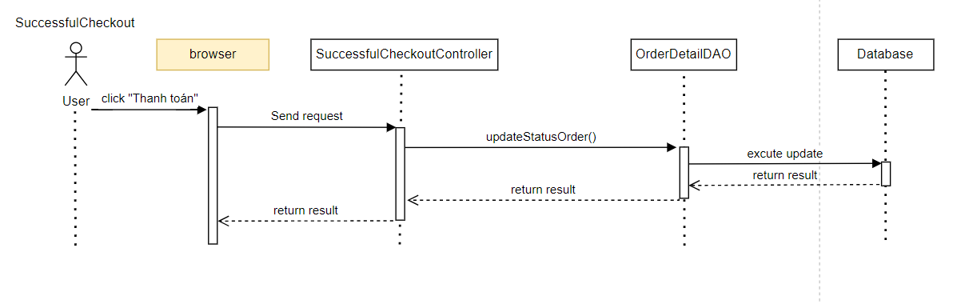

### d. Database queries

* "INSERT INTO `Order` " +

"(`total_cost`, `fullName`, `mobile`, `address`, `userId`, `note`) " +

"VALUES (?, ?, ?, ?, ?, ?)"

* "SELECT * FROM Cart WHERE user_id = ?"
* "INSERT INTO `Order_Detail`\n"

+ " (`product_price`, `quantity`, `order_id`, `product_id`, `product_name`, `total_cost`)\n"

+ "VALUES\n"

+ " (?,?,?,?,?,?)";

* "DELETE FROM `Cart` "

+ "WHERE `user_id` = ?"

* SELECT * FROM `Order` WHERE `userId` = ? AND `status_order` IS NULL
* "SELECT * FROM `User` WHERE role_id = 3\n"

+ "ORDER BY RAND()\n"

+ "LIMIT 1;"

* "UPDATE `Order`\n"

+ "SET `saler_id` = ?\n"

+ "WHERE `order_id` = ?;"

* "UPDATE `Order` " +

"SET `status_order` = ? " +

"WHERE `order_id` = ?"

* SELECT *\n"

+ "FROM `Order_Detail`\n"

+ "WHERE order_id = ?"

* "UPDATE `Product` " +

"SET `quantity` = (quantity - ?) " +

"WHERE `product_id` = ?";

* "SELECT customer_id, customer_name, customer_email, customer_mobile "

+ "FROM books_shop_online.customer "

+ "WHERE customer_name = ? AND customer_email = ? OR customer_mobile = ?"

* "INSERT INTO books_shop_online.customer "

+ "(customer_name, customer_email, customer_mobile) "

+ "VALUES (?, ?, ?)"